|  |  |  |
| --- | --- | --- |
|  | Monarch-A-logo.jpg |  |

Seventh Framework Programme   
Theme 9 Space FP7-SPA.2009.1.1.02

Monitoring of climate change issues (extending core service activities)

Grant agreement for: Collaborative Project (generic).

Project acronym: **MONARCH-A**

Project title: **MONitoring and Assessing Regional Climate change in High latitudes and the Arctic**

Grant agreement no. 242446

Start date of project: 01.03.10

Duration: 36 months

Project coordinator: Nansen Environmental and Remote Sensing Center, Bergen, Norway

**D1.4.3: Integrated Fire Products for Carbon & Climate Modelling**

Due date of deliverable: 31.08.2012

Actual submission date: 30.08.2012

Organization name of lead contractor for this deliverable: USFD

|  |  |  |
| --- | --- | --- |
| Project co-funded by the European Commission  within the Seventh Framework Programme, Theme 6 Environment | | |
| Dissemination Level | | |
| PU | Public |  |
| PP | Restricted to other programme participants (including the Commission) |  |
| RE | Restricted to a group specified by the consortium (including the Commission) |  |
| CO | Confidential, only for members of the consortium (including the Commission) |  |

|  |  |  |  |
| --- | --- | --- | --- |
| **ISSUE** | **DATE** | **CHANGE RECORDS** | **AUTHOR** |
| 0 |  |  |  |
|  |  |  |  |
|  |  |  |  |
|  |  |  |  |
|  |  |  |  |
|  |  |  |  |
|  |  |  |  |
|  |  |  |  |
|  |  |  |  |
|  |  |  |  |
|  |  |  |  |
|  |  |  |  |

|  |
| --- |
| ***SUMMARY*** |
| Fire is an endemic process at high latitudes, connected to a range of other land surface properties, such as land cover, biomass and permafrost, and intimately linked to the carbon balance of the high latitude land surface. Much of our current understanding of these links and their climate consequences is through land surface models, so it is important to ensure that, for their credibility, these models should be consistent with available data. Over the vast pan-boreal region, a key source of information on fire is satellite data, as described in D1.4.1. Analysis of the various fire products available at high latitudes indicated that the most complete integration of products was already available through the latest version of the Gloabl Fire Emissions Database (GFED v3.1 ), which combines satellite-derived estimates of burnt area with satellite measurements of active fires. Although of major importance at low latitudes, the Fire Radiative Power product is not sufficiently mature, nor available in a long enough data record, for its inclusion in a high latitude fire product, although it is likely to be come more important as methods to combine polar-orbiting and geostationary satellite data develop. Comparisons between satellite-based burnt area data from the Global Fire Emissions Database (GFED) and three Dynamic Vegetation Models (LPJ-WM, CLM4CN, SDGVM) indicate that all models fail to represent the observed spatial and temporal properties of the fire regime. Although the three Dynamic Vegetation Models give comparable values of the boreal Net Biome Production (NBP), fire emissions are found to differ by a factor four between the models, because of widely different estimates of burnt area and because of different parameterizations of the fuel load and combustion process. Including a more realistic representation of the fire regime derived from satellite data in the models shows that, for northern high latitudes: i) severe fire years do not coincide with source years or vice versa; ii) the inter-annual variability of fire emissions does not significantly affect the inter-annual variability of NBP; iii) overall biomass values alter only slightly, but the spatial distribution of biomass exhibits changes. We also demonstrate that it is crucial to alter the current representations of fire occurrence and severity in land surface models if the links between permafrost and fire are to be captured, in particular the dynamics of permafrost properties, such as variations in active layer depth. This is especially important if models are to be used to predict the effects of a changing climate, because of the consequences of permafrost changes for greenhouse gas emissions, hydrology and land cover.  A version of this report has been submitted to Global Biogeochemical Cycles and is currently under review. |

***MONARCH-A CONSORTIUM***

|  |  |  |  |
| --- | --- | --- | --- |
| **Participant no.** | **Participant organisation name** | **Short name** | **Country** |
| 1 (Coordinator) | Nansen Environmental and Remote Sensing Center | NERSC | NO |
| 2 | The University of Sheffield | USFD | UK |
| 3 | Universität Hamburg | UHAM | NO |
| 4 | Centre National de la Recherche Scientifique | CNRS | FR |
| 5 | Scientific foundation Nansen International Environmental and Remote Sensing Center | NIERSC | RU |
| 6 | Universitetet i Bergen | UiB | NO |
| 7 | Danmarks Tekniske Universitet | DTU | DK |
| 8 | Institut Francais de Recherche pour l'Exploitation de la Mer | IFREMER | FR |

No part of this work may be reproduced or used in any form or by any means (graphic, electronic, or mechanical including photocopying, recording, taping, or information storage and retrieval systems) without the written permission of the copyright owner(s) in accordance with the terms of the MONARCH-A Consortium Agreement (EC Grant Agreement 242446).

All rights reserved.

This document may change without notice.

# Table of Contents

Table of Contents 5

1 Introduction 8

2 Description of models 10

3 Earth Observation and climate data 12

3.1 Satellite-based land cover products 12

3.2 Satellite-based fire products 14

3.3 Climate data 15

4 Results 16

4.1 Model-based estimates of Net Biome Production (NBP) 16

4.2 Comparing model estimates of burned area with satellite observations 21

4.3 Estimated fire emissions 27

4.4 Model parameterizations of fire emissions 30

5 Discussion 33

5.1 Available data on fire processes at high latitudes 33

5.2 The effects of improving the spatio-temporal description of fire on estimates of high latitude processes 34

5.2.1 Modifications to the SDGVM and their consequences 35

5.2.2 Modifications to LPJ-WM and their consequences for permafrost 38

5.3 Land cover effects on NBP and fire processes 42

6 Conclusions 45

7 References 47

***List of Figures***

[Figure 1: Annual NBP (in Tg C yr-1) from the three models averaged over 1981-2006 for latitudes northward of 50o N. 17](#_Toc333826332)

[Figure 2: Pan-boreal estimates of NPP, Rh, NEP, fire emissions and NBP for the three models. NPP and Rh are given in units of PgC yr-1, while the scale for the other three fluxes is an order of magnitude less. 19](#_Toc333826333)

[Figure 3:Averageannual fire emissions (in Tg C yr-1) from boreal latitudes averaged over 1981-2006 for the three models. 20](#_Toc333826334)

[Figure 4:Percentage of each grid cell burned annually at boreal latitudes averaged over 1981-2006 for the three models and over 1997-2009 for GFED-BA. The percentage burnt is shown on a log scale. 23](#_Toc333826335)

[Figure 5:Percentage of burned area per grid cell in 2000 and 2002 over N. America for the three models and GFED-BA. 25](#_Toc333826336)

[Figure 6:(left) Total area burnt per year (Mha yr-1) for the pan-boreal region, N. America and Eurasia as calculated by the three models and given by GFED-BA and MODIS-BA; (right) the corresponding fire emissions (Tg C yr-1) for the models and GFED. 26](#_Toc333826337)

[Figure 7:Regression of annual fire emissions (Tg C) against annual burned area (Mha) for the three DVMs (1981-2006) and GFED (1997-2009) over N. America and Eurasia. 29](#_Toc333826338)

[Figure 8: Burned area (in Mha) from GFED-BA, SDGVM and the SDGVM with the adjusted burnt area (denoted as SDGVM\*) for the pan-boreal region for 1997-2006. 36](#_Toc333826339)

[Figure 9:Time series (1960-2006) of the de-trended NBP (solid lines, left y-axis) and fire emissions (dashed lines, right y-axis) for SDGVM and its modified version, SDGVM\*. 37](#_Toc333826340)

[Figure 10:Percentage difference in biomass between modified and unmodified SDGVM calculations, i.e. 100 x (SDGVM\* – SDGVM) / SDGVM, averaged over 1997-2006. 38](#_Toc333826341)

[Figure 11:CDF of fractional annual burnt area per disturbed grid cell for GFED-BA and LPJ-WMa. On average, GFED-BA indicates about 8% of grid cells to be disturbed each year. Values with percentage burnt area exceeding 40% have probability less than 0.0012 so are omitted from the CDF plot. 39](#_Toc333826342)

[Figure 12: (top) Monthly soil temperatures for altered and original boundary conditions (B.C.) at depth of 0.1 m produced by LPJ-WMa at a site which experienced more than 99% of burn; the arrow marks the year of the fire disturbance. (bottom) Thaw depth averaged over summer months for the same sites. 42](#_Toc333826343)

[Figure 13: (top) Pan-boreal fractions of three generic cover types (trees, herbaceous cover and bare ground) derived from the four land cover maps. (bottom) Average values of pan-boreal NPP, Rh, NEP, fire emissions and NBP calculated by SDGVM over the period 1981-2006 when driven with GlobCover, MODIS VCF, MODIS LC and GLC2000. 44](#_Toc333826344)

***List of Tables***

[Table 1:Annual NBP (in Tg C yr-1) averaged over 1981-2006 for the three models over N. America, Eurasia and the pan-boreal region. 18](#_Toc333826348)

[Table 2:Ratiobetween average annual fire emissions and average NBP for 1981-2006 calculated from the three DVMs for N. America, Eurasia and pan-boreal latitudes. 19](#_Toc333826349)

[Table 3:Annual fire emissions (in Tg C yr-1) averaged over 1981-2006 for the three models over N. America, Eurasia and pan-boreal latitudes. 21](#_Toc333826350)

[Table 4:Annual burned area (in Mha yr-1) averaged over 1981-2006 for the three models over N. America, Eurasia and pan-boreal latitudes. Also shown is the burned area from GFED-BA averaged over 1997-2009 for the same regions. 23](#_Toc333826351)

[Table 5:Annual carbon emissions (Tg C yr-1) averaged over 1981-2006 for the three models over N. America, Eurasia and pan-boreal latitudes. Also shown are the emissions from GFED averaged over 1997-2009 for the same regions. 28](#_Toc333826352)

[Table 6: Slopes, intercepts and R2 values for best linear fits to the plots of annual fire emissions vs burnt area for GFED and the three Dynamic Vegetation Models for N. America and Eurasia. 29](#_Toc333826353)

[Table 7: Definitions of fuel load and combustion completeness in the three DVMs and in the CASA model used by GFED. AGB and BGB refer to above- and below-ground biomass respectively. 31](#_Toc333826354)

# Introduction

Land masses at boreal latitudes, defined in this paper as poleward of 50o N, are characterized by huge expanses of boreal forest, wetlands, peatlands and tundra lying on organic soils that account for 50% of the global below-ground organic carbon [[*Tarnocai et al.*, 2009](#_ENREF_57)]; Northern peatlands alone hold a third of the global soil organic matter [[*Turetsky et al.*, 2002](#_ENREF_61)]. These various biomes are all to some extent underlain by permafrost (continuous, widespread or scattered). Overall these regions hold a third of the global terrestrial carbon [[*McGuire et al.*, 1995](#_ENREF_37)]. Low average annual air temperatures and high soil water content, in part arising from perched water tables due to permafrost, have caused the rate of carbon deposition to be on average higher than decomposition through the Holocene era, leading to net accumulation of carbon. Atmospheric inversion studies show that the high latitude land surface continues to act as a carbon sink estimated by [[*Gurney et al.*, 2003](#_ENREF_22); [*Rodenbeck et al.*, 2003](#_ENREF_49)]) as 0.23 PgC yr-1 and by Rodenbeck *et al.* (2003) as 0.4 PgC yr-1.

Projections of the temperature response to climate show considerable warming of northern boreal latitudes in the 21st century [[*Christensen et al.*, 2007](#_ENREF_5); [*Serreze and Francis*, 2006](#_ENREF_51)]. Since 1900, the temperature in the Arctic has increased by 0.09 ºC per decade [[*Corell*, 2005](#_ENREF_8)] and is projected to increase by 0.25-0.75 ºC per decade over the next 100 years, with associated increases in precipitation [[*Christensen et al.*, 2007](#_ENREF_5)]. However, the effects of increased temperature on physical processes in the Arctic, the sensitivity of the carbon cycle to such changes and the size of climate-carbon cycle feedbacks in this region remain highly uncertain [[*Friedlingstein et al.*, 2006](#_ENREF_16); [*McGuire et al.*, 2009](#_ENREF_38)]. Such processes include: a) decrease of snow cover and its effect on albedo and the radiation budget, b) changes in the fire regime with fire resistant species benefiting from increased disturbance, c) permafrost thawing and water table changes in peatlands with subsequent release of carbon and methane, and d) increased photosynthesis with shrub and tree establishment at higher latitudes. For example, even though global circulation models running projected climate scenarios show an increase in fire activity in boreal forests [[*Stocks et al.*, 1998](#_ENREF_55)], analysis of the last 15 years of active fire data show no statistically significant increase [[*Arino et al.*, 2012](#_ENREF_1)].

The main source of uncertainty in predictions for the next 30 years is the lack of adequate information on initial conditions, whereas beyond that it arises from errors in climate model formulation and parameterization [[*Cox and Stephenson*, 2007](#_ENREF_9)]. A significant amount of work has been undertaken in recent years to address the initial value problem and to improve parameterizations by establishing a set of Essential Climate Variable (ECV) datasets under the framework established by the Global Climate Observing System [[*GCOS*, 2004](#_ENREF_17); [2010](#_ENREF_18)]. The study reported here forms part of this endeavor, and arises from the European Union Framework Programme 7 “Monitoring and assessing regional climate change in high latitudes and the Arctic” (MONARCH-A), whose aim is to generate a multi-disciplinary set of ECVs relevant to high latitude processes, and to elucidate their use in quantifying the forcing and feedback mechanisms associated with changes in terrestrial carbon and water fluxes, sea level and ocean circulation and the marine carbon cycle in the high latitude and Arctic regions.

In this paper we focus on fire processes at high latitudes. Marked differences are found between the properties of high latitude fires observed by satellites and their representations in three state–of–the–art land surface models, two of which are embedded in IPCC-standard climate models. By altering the parameterization of fire-related model processes to produce burned area outputs that better fit the observed temporal and spatial statistical characteristics of the data, we investigate whether these differences have significant consequences for estimates of the net carbon balance of boreal latitudes, i.e. the Net Biome Production (NBP) and its inter-annual variability, and two other terrestrial ECVs, biomass and permafrost. We also use model calculations to assess whether our conclusions are significantly affected by uncertainty in land cover.

# Description of models

Below we provide brief descriptions of the three dynamic vegetation models (DVMs) used in this study, commenting mainly on their relevance to studying carbon processes at high latitudes. Fuller descriptions of the models are available from the references cited. Two of these models, the Lund-Potsdam-Jena (LPJ) dynamic global vegetation model [[*Sitch et al.*, 2003](#_ENREF_52)] and the Community Land Model 4 (CLM4) [[*Kloster et al.*, 2010](#_ENREF_29)], are embedded in coupled climate models available within MONARCH-A (the Bergen Climate Model BCM [[*Tjiputra et al.*, 2010](#_ENREF_60)] and the Norwegian Earth System Model (NorESM) respectively). The third model, the Sheffield Dynamic Global Vegetation Model (SDGVM), is a stand-alone terrestrial carbon-water model chosen because of the ease with which it can be modified and used to test hypotheses within this study.

LPJ-WM [[*Wania et al.*, 2009](#_ENREF_65)] is an enhanced version of LPJ tailored to high-latitude biomes, with adaptations to model peatland vegetation, peatland hydrology and permafrost dynamics. It includes two new Plant Functional Types (PFTs), flood-tolerant C3 graminoids and sphagnum mosses, which dominate herbaceous cover for latitudes greater than 50º N. For peatland hydrology a new parameterization was introduced which considers the specific dynamics of the acrotelm and cacotelm layer simulated in the model. To estimate permafrost behavior and permafrost active layer depth, soil temperature was modeled as a function of depth using a one-dimensional energy flow formulation; this required the hydrology module [[*Gerten et al.*, 2004](#_ENREF_19)] to be modified to permit a greater number of soil layers.

CLM4CN [[*Lawrence et al.*, 2011](#_ENREF_32)] is an updated version of CLM4, the land component of the Community Earth System Model (CESM) [[*Collins et al.*, 2006](#_ENREF_6)], with a prognostic Carbon-Nitrogen biochemical model. CLM4CN has specific parameterizations for the thermal and hydraulic properties of organic soil [[*Lawrence and Slater*, 2008](#_ENREF_30)], incorporates boreal PFTs, and its soil temperature profiles and permafrost extent perform well when compared to observations [[*Lawrence et al.*, 2008](#_ENREF_31)].

The SDGVM [[*Woodward and Lomas*, 2004](#_ENREF_66); [*Woodward et al.*, 1995](#_ENREF_67)] is one of the earliest of a host of DVMs which are now available. It has been used in several DVM comparison studies [[*Cramer et al.*, 2001](#_ENREF_10); [*Le Quere et al.*, 2009](#_ENREF_33); [*Piao et al.*, 2009](#_ENREF_42)], and has proven to be a good indicator of the general trends produced by DVMs at global and regional scales. It contains no specific adaptations to high latitude conditions, e.g., it does not contain a permafrost module, but is well-suited to investigating the effects of land cover and some aspects of fire.

# Earth Observation and climate data

## Satellite-based land cover products

Models can use two approaches to determine the spatial and temporal behavior of plant distribution, the “natural vegetation” approach, in which survival and establishment of PFTs are determined by climatological conditions and do not depend on other external information, or “constrained vegetation”, where land cover maps, typically derived from satellite data, are used to specify the distribution of the PFTs. In this study, LPJ-WM uses natural vegetation, with climate envelopes and competition for space and water determining PFT distribution, while SDGVM and CLM4CN use external land cover information. Such reference land cover data can also be used to assess how realistic are the land cover maps produced under the natural vegetation approach.

The conversion of external land cover data into a form suitable for models requires some amalgamation of classes since, typically, the number of land cover classes supplied is around 15-25, but most models use a limited number of PFTs (for high latitudes, LPJ-WM and CLM4CN use 10, and SDGVM requires 7). While some classes convert straightforwardly into PFTs, e.g. ‘Evergreen Needleleaf Forest’, for others, particularly mixed classes such as ‘Mixed Forest’ or ‘Mosaic Forest/Grassland’ the assignment of a class to a PFT or mixture of PFTs is less clear and is a matter of judgment, which, in tandem with differences between land cover maps, gives rise to some uncertainty in carbon calculations [[*Poulter et al.*, 2011a](#_ENREF_44); [*Poulter et al.*, 2011b](#_ENREF_45)].

Three global land cover data sets derived from EO data are particularly well-known and influential:

1. Global Land Cover 2000 (GLC2000) [[*Bartholome and Belward*, 2005](#_ENREF_3)] is derived from the VEGETATION instrument on-board the SPOT-4 satellite and is only available for the year 2000. Pixels of 0.009º spatial resolution are classified into 23 classes based on the Land Cover Classification System (LCCS) [[*Di Gregorio and Jansen*, 2000](#_ENREF_12)].
2. GlobCover [[*Arino et al.*, 2008](#_ENREF_2)] was created from data acquired with the MERIS sensor on-board the ENVISAT satellite and is the highest resolution satellite-based global land cover map ever produced. Two datasets exist, for 2005 and 2009, each with a spatial resolution of 300 m and 23 classes based on LCCS. Only the former was used here because it is closer to the period dealt with in this study.
3. MODIS Collection 5 Land Cover MCD12C1 (MODIS LC) [[*Friedl et al.*, 2010](#_ENREF_15)] is derived from data from the MODIS Terra & Aqua satellites and is available at 0.05º resolution for each of the years 2001-2007, of which 2001 was used. Pixels are classified into 17 classes defined according to the International Geosphere Biosphere Programme [[*IGBP*, 1990](#_ENREF_25)].

Most of the calculations using SDGVM are based on GLC2000, but Section 5.3 assesses the differences in carbon fluxes arising from using other land cover products. CLM4CN incorporates for 1850-1995 a transient land cover and land use driven by the Land-Use History A dataset [[*Hurtt et al.*, 2006](#_ENREF_24)], while the present day distribution of PFTs is provided by a variety of EO data. As already noted, LPJ-WM has a distribution of PFTs determined using the “natural vegetation” concept.

A fourth important land cover dataset is the MODIS Vegetation Continuous Fields (MODIS VCF) MOD44B land cover product [[*Hansen et al.*, 2003](#_ENREF_23)] which uses data derived from MODIS visible bands. By employing a regression tree algorithm and observing the salient points in the phenological cycle, it assigns to each pixel a percentage of just three types of cover: tree, herbaceous vegetation and bare ground coverage. Such a continuous classification scheme differs from the discrete approach of other land cover data sets, which instead assign the dominant class to each pixel. Continuous descriptors are advantageous as they portray more accurately the spatial heterogeneity of vegetation, while the lack of fixed typological classes makes continuous classifications readily adaptable to the different PFTs in various vegetation models [[*Defries et al.*, 1995](#_ENREF_11)]. The product exists at 500 m resolution and for the year 2001, the only available record. This is exploited with SDGVM in Section 5.3.

## Satellite-based fire products

Three types of fire products are obtained from EO data: active fires, burned area and fire radiative power (FRP). Active fire products, such as the ATSR World Fire Atlas [[*Arino et al.*, 2012](#_ENREF_1)] and the MODIS MOD/MYD14CMH [[*Giglio*, 2010](#_ENREF_20)] product, use the thermal channels of sensors to register anomalies of the surface temperature and thus identify hotspots. Burned area products, like the MODIS MCD45A1 (MODIS-BA) [[*Roy et al.*, 2008](#_ENREF_50)] and the Global Fire Emission Database-Burned Area (GFED-BA) [[*Giglio et al.*, 2010](#_ENREF_21)], are derived by identifying reflectance changes in the visible channels of the sensor; GFED-BA also makes use of active fire products in its retrieval algorithm. If a burned area map is used in conjunction with a land cover map and process model, it is possible to estimate carbon emissions (as is done to produce the Global Fire Emissions Database [GFED] [[*van der Werf et al.*, 2010](#_ENREF_63)]). Finally, Fire Radiative Power, as in the MODIS product MOD/MYD14CMH, is obtained from the thermal channels of a sensor and is a measure of the rate of radiant heat, which is related to the rate at which fuel is consumed [[*Wooster et al.*, 2005](#_ENREF_69)].

Both MODIS-BA and GFED-BA are examined in this study. MODIS-BA uses images acquired from the MODIS satellite series and calculates the date of burn for each 500 m pixel, from which burned area can be retrieved. Data are available for the years 2000-2011, but only for latitudes below 70º N. GFED-BA merges several types of EO data and products, of which the majority come from MODIS images, to create a global burned area data set at 0.5º resolution for the years 1996-2010; this is the same resolution as is used in all the models in this study.

The GFED dataset contains estimates of carbon dioxide and other trace gas emissions from fire derived by a combination of satellite observations and modeling. Earth observation data of the fraction of available photosynthetically active radiation are used to derive Net Primary Production, and the carbon produced is allocated to plant types according to a prescribed land cover data set. The Carnegie-Ames-Stanford-Approach (CASA) biochemical model [[*Potter et al.*, 1993](#_ENREF_43)] is then used to calculate the carbon pools in each 0.5º grid-cell, e.g. biomass, litter, etc., with the GFED-BA product providing an estimate of burned area. Emissions for each carbon pool are then calculated as a function of monthly burned area, mortality and combustion completeness, the last of which is calculated as a linear function of soil moisture. On a continental scale the greatest uncertainties in carbon emissions are found in the boreal regions [[*van der Werf et al.*, 2010](#_ENREF_63)].

Although active fire products cannot be directly used in assessing model performance, they are important as they contribute to the GFED-BA burned area product. Fire Radiative Power has great potential for constraining models since it provides direct estimates of emissions from biomass burning [[*Roberts and Wooster*, 2008](#_ENREF_48)], but no consistent dataset for the boreal region yet exists and hence it is not used in this study.

## Climate data

LPJ-WM and SDGVM were driven by the CRU TS 3.0 (Climate Research Unit Time-Series) (Mitchell & Jones, 2005) (0.5º resolution, 1901-2006) and CLM4CN by the CRU+NCEP (National Centers for Environmental Prediction) climatology, based on CRU 2.0 and the NCEP reanalysis [[*Kanamitsu et al.*, 2002](#_ENREF_27)], also at 0.5º resolution for the period 1949 to 2009. Before being driven by the complete climatology, the models undergo a spin-up phase, during which they are forced with a subset of the climate dataset which cycles periodically until the carbon pools stabilize.

# Results

In terms of climate feedbacks, the most important carbon quantity is the NBP, since this is the overall sink strength of the land surface. If lateral transport fluxes are ignored, the NBP contains three component fluxes:

NBP = NPP – Rh - D = NEP – D

where NPP (Net Primary Production) is the carbon available for plant growth from photosynthesis after autotrophic respiration has been subtracted, Rh is heterotrophic respiration, NEP = NPP – Rh is Net Ecosystem Production and D is the disturbance flux, which we treat here as exclusively caused by fire even though other forms of disturbance can be included in CLM4CN. This allows a meaningful comparison with the available datasets, which only deal with burnt area and fire emissions. However, in situ measurements indicate that other types of disturbance, for example insect damage and logging, cause significantly greater losses of carbon than fire over large parts of central Siberia [[*Quegan et al.*, 2011](#_ENREF_47)].

## Model-based estimates of Net Biome Production (NBP)

**Fig. 1** shows maps of average NBP over the period 1981-2006 estimated by the three DVMs, while **Table 1** gives the aggregated values for the pan-boreal region and for N. America and Eurasia. All three models find the boreal region to be a net sink. LPJ-WM gives the largest values both overall and in each continent, being a factor 1.5 – 2 larger than CLM4CN, while SDGVM takes intermediate values. Except for CLM4CN, the model estimates lie within the 300-600 Tg C yr-1 range of estimates of the net uptake of CO2 poleward of 45ºN for the 20th century found by a number of inventory studies [[*McGuire et al.*, 2009](#_ENREF_38)].

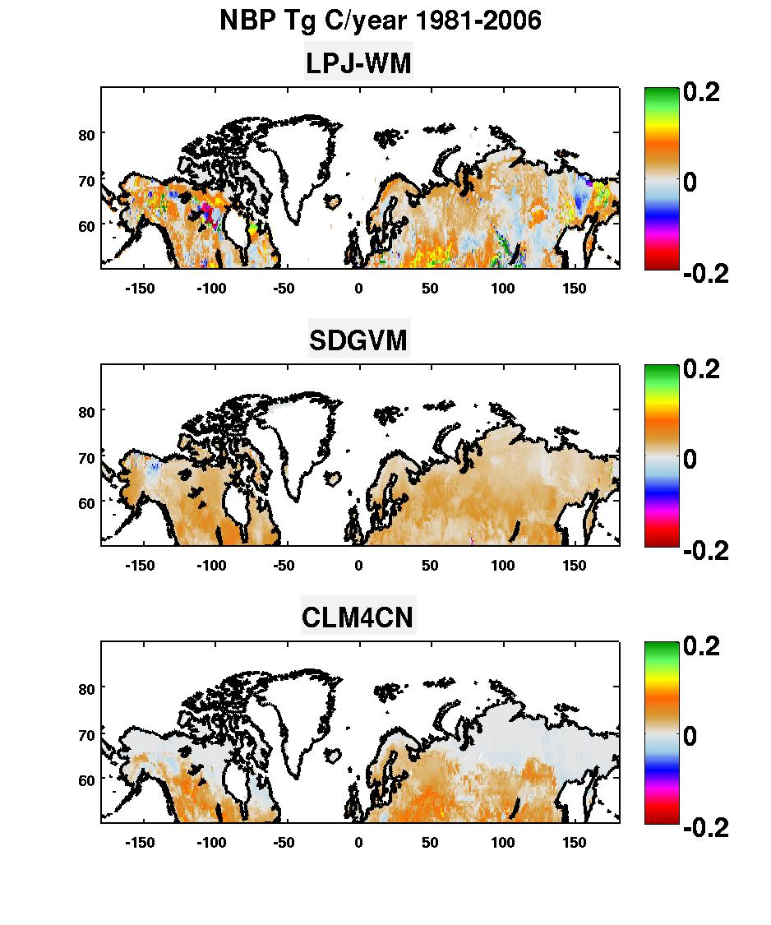

Figure 1: Annual NBP (in Tg C yr-1) from the three models averaged over 1981-2006 for latitudes northward of 50o N.

|  |  |  |  |
| --- | --- | --- | --- |
| **NBP (Tg C yr-1)** | LPJ-WM | SDGVM | CLM4CN |
| N. America | 166 | 154 | 81 |
| Eurasia | 342 | 286 | 204 |
| Global | 508 | 440 | 284 |

Table 1:Annual NBP (in Tg C yr-1) averaged over 1981-2006 for the three models over N. America, Eurasia and the pan-boreal region.

There are marked differences in spatial structure between the three models. LPJ-WM exhibits much higher spatial variability: 31% of its grid cells, distributed across all latitude bands, are sources, yielding average annual emissions of 118 Tg C yr-1; these grid cells exhibit no special bias towards a particular PFT. For CLM4CN, 42.5% of the grid cells are weak sources, most of which occur at latitudes above 60º N, but these emit only 24.5 Tg C yr-1, a factor 5 less than LPJ-WM. SDGVM is quite different, exhibiting fairly homogeneous uptake across the pan-boreal region, with fewer than 5% of the grid cells acting as sources.

All three models show an increasing trend in NBP over the period 1981-2006, with rates of increase given by 8.3 Tg C yr-2 for LPJ-WM, 14.4 Tg C yr-2 for SDGVM and 3.4 Tg C yr-2 for CLM4CN; however, of these only the SDGVM value is statistically significant. Atmospheric inversion studies reviewed by McGuire (2009) find the inter-annual variability of NBP (defined as temporal standard deviation) for the terrestrial regions of the Arctic during the 1990s to have a value of up to ± 500 Tg C yr-1, but for the same period the models give lower values: ± 300 Tg C yr-1 for LPJ-WM, ± 170 Tg C yr-1 for SDGVM and ± 153 Tg C yr-1 for CLM4CN. The corresponding values for the period 1981-2006 are respectively ± 309, ± 148 and ± 143 Tg C yr-1.

The pan-boreal aggregate values of the components making up the NBP are shown in **Fig. 2**. For all three models, the ratio of NPP to Rh is very similar, ranging from 1.08 to 1.10. LPJ-WM gives higher NEP than both SDGVM and CLM4CN, the last of which exhibits very low productivity for regions north of 65º N where the Boreal Shrub PFT is dominant. The large differences seen in NEP are compensated by large differences in emissions due to fire, which tend to equalize the NBP between the three models. There are associated disagreements between the models about the significance of fire in NBP, as is shown in **Table 2**, which gives the ratio of fire emissions to NBP for N. America, Eurasia and for the pan-boreal region. Fire emissions exceed NBP for LPJ-WM, but for the other two models are less than NBP. Fire plays a particularly significant role in LPJ-WM, destroying on average equivalent to 57% of the NEP, but only around 38% for the other two models.

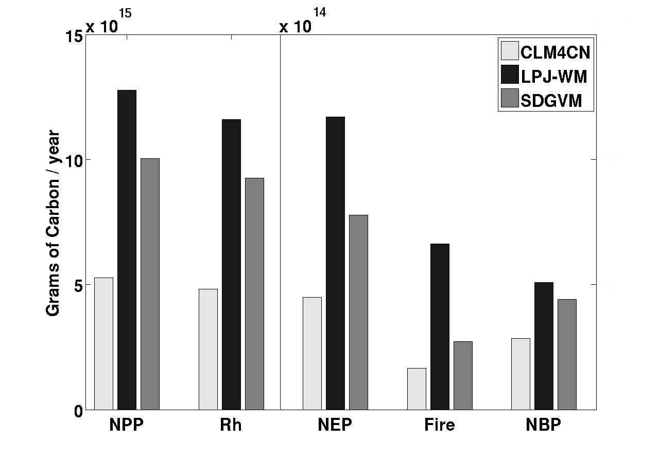

Figure 2: Pan-boreal estimates of NPP, Rh, NEP, fire emissions and NBP for the three models. NPP and Rh are given in units of PgC yr-1, while the scale for the other three fluxes is an order of magnitude less.

|  |  |  |  |
| --- | --- | --- | --- |
| **Fire emissions/NBP** | LPJ-WM | SDGVM | CLM4CN |
| N. America | 1.12 | 0.46 | 0.68 |
| Eurasia | 1.38 | 0.70 | 0.54 |
| Global | 1.31 | 0.62 | 0.58 |

Table 2:Ratiobetween average annual fire emissions and average NBP for 1981-2006 calculated from the three DVMs for N. America, Eurasia and pan-boreal latitudes.

The continental scale fire emissions from the models are summarized in **Fig. 3** and **Table 3**. The emissions calculated by LPJ-WM are around a factor 4 greater than those from CLM4CN in both continents, and around 2-2.5 greater than from SDGVM. LPJ-WM also exhibits far greater spatial variability than the other two models, with significant fire fluxes at high latitudes in the Siberian Far East. In contrast, CLM4CN calculates no fire emissions north of 65o N, except for northern Scandinavia. SDGVM is similar to CLM4CN, but with emissions extending to much higher latitudes.

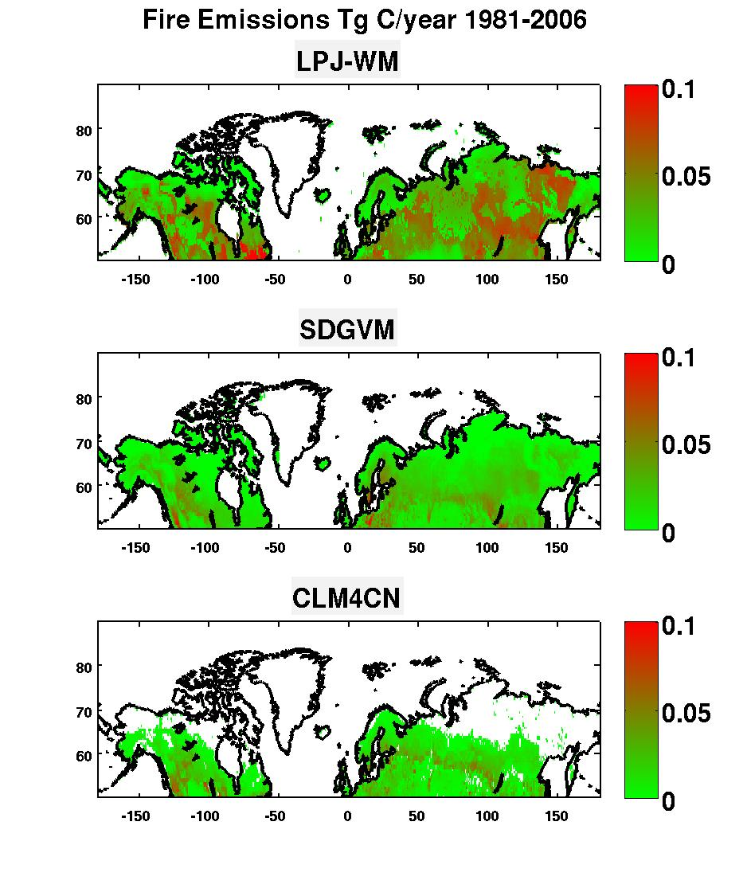

Figure 3:Averageannual fire emissions (in Tg C yr-1) from boreal latitudes averaged over 1981-2006 for the three models.

|  |  |  |  |
| --- | --- | --- | --- |
| **Fire emissions (Tg C yr-1)** | LPJ-WM | SDGVM | CLM4CN |
| N. America | 192 | 71 | 55 |
| Eurasia | 471 | 201 | 110 |
| Global | 663 | 272 | 164 |

Table 3:Annual fire emissions (in Tg C yr-1) averaged over 1981-2006 for the three models over N. America, Eurasia and pan-boreal latitudes.

Hence, for all models, fire is a very significant factor in determining the overall carbon balance and whether a given grid cell will act as a sink or a source (e.g. in LPJ-WM, 30% of the grid cells that are net sources were sinks before the fire emissions were subtracted). It is therefore important to establish whether measurements support the model estimates of fire emissions and the representation of the processes from which they arise.

## Comparing model estimates of burned area with satellite observations

Comparing models and how they relate to data is aided by the fact that all three models follow similar approaches to producing fire emissions. The burned area of each grid cell is first calculated as a function of one or more climate variables, usually temperature and moisture. It is then weighted against the available fuel in the grid cell, and finally, according to rules that govern the combustion process, the fire emissions are calculated. A crucial observable quantity is therefore burned area, which is derived in different ways between the models.

In LPJ-WM, the probability of fire for a grid cell is calculated daily as a function of litter moisture, with temperature and available litter acting as limiting factors [[*Thonicke et al.*, 2001](#_ENREF_58)]. By summing the daily probability over the course of the year the annual length of the fire season is calculated, from which the annual fraction burnt in each grid cell is extracted. CLM4CN incorporates the LPJ-WM algorithm to estimate the burned area [[*Kloster et al.*, 2010](#_ENREF_29)] with certain modifications by [[*Thornton et al.*, 2007](#_ENREF_59)] to accommodate the sub-daily time step used by CLM and to adapt to the specifics of its variables, not all of which have exact equivalents in LPJ-WM. SDGVM produces burned area by an empirical model driven by monthly averages of temperature and precipitation, and limits the fire return interval (FRI) to lie between 2 and 800 years, which in land surface process models is defined as the time required for successive fire events to cumulatively burn an area equal to the area of interest, usually a grid cell of assigned spatial resolution. Hence the FRI is equal to the reciprocal of the annual average fraction of area burnt.

*Observed and modeled spatial variability in burned area*

The annual average fraction of burned area per grid cell calculated over the period 1981-2006 by the three models is shown in **Fig. 4** (note the log scale) and summarized in **Table 4**. With the exception of CLM4CN northwards of 65º, every grid cell in all three models shows some degree of burn. In LPJ-WM and CLM4CN this is fairly uniform and mostly less than 1%, while SDGVM exhibits more structure, with grid-cells in southern Eurasia and the western US exhibiting average burnt area up to 4%. The overall average annual burnt area in SDGVM is 17.2 Mha yr-1, which is around 60% more than LPJ and 100% more than CLM4CN.

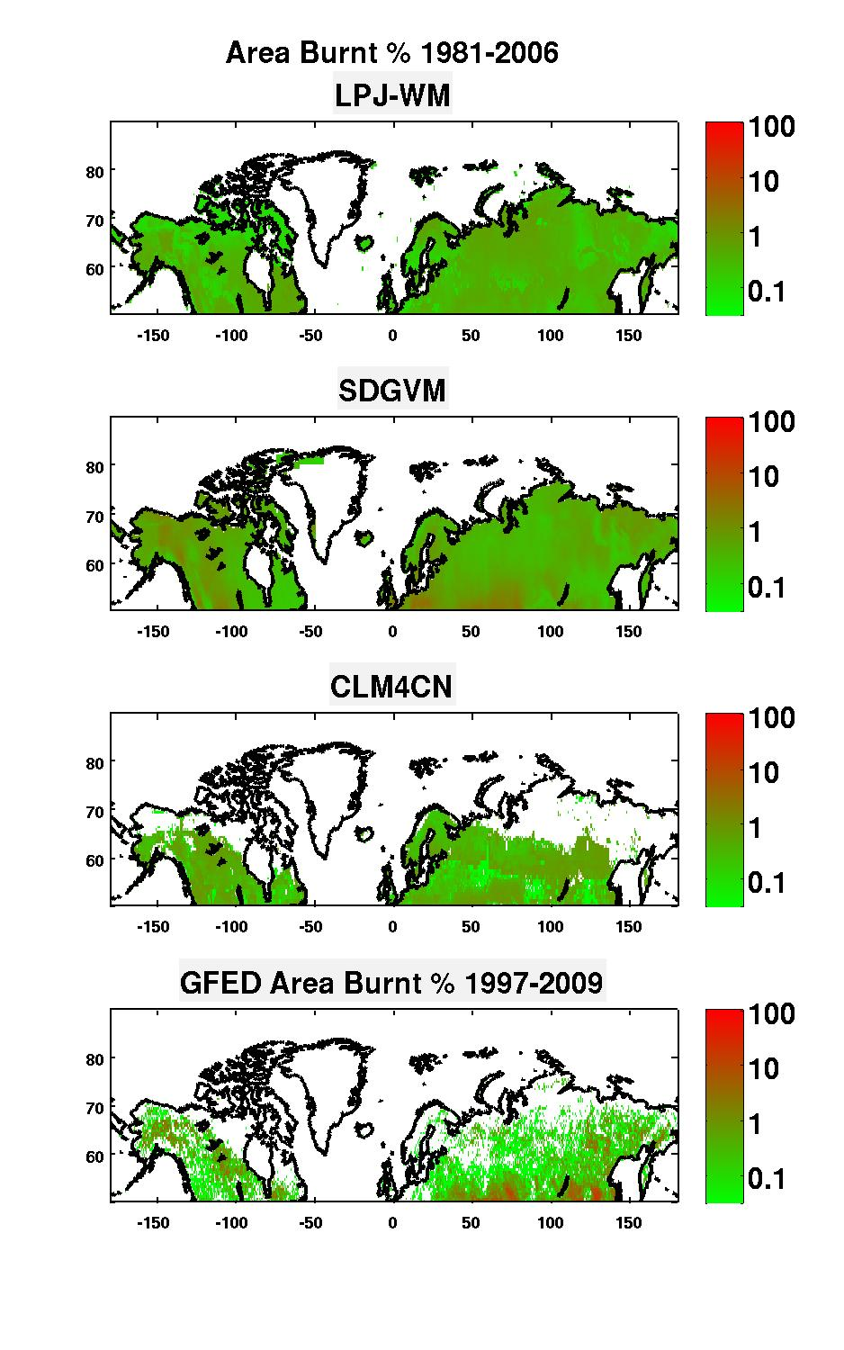

Figure 4:Percentage of each grid cell burned annually at boreal latitudes averaged over 1981-2006 for the three models and over 1997-2009 for GFED-BA. The percentage burnt is shown on a log scale.

|  |  |  |  |  |
| --- | --- | --- | --- | --- |
| **Burned Area (Mha yr-1)** | LPJ-WM | SDGVM | CLM4CN | GFED-BA |
| N. America | 3.4 | 5.4 | 2.9 | 2.04 |
| Eurasia | 7.2 | 11.8 | 5.8 | 10.0 |
| Global | 10.6 | 17.2 | 8.7 | 12.04 |

Table 4:Annual burned area (in Mha yr-1) averaged over 1981-2006 for the three models over N. America, Eurasia and pan-boreal latitudes. Also shown is the burned area from GFED-BA averaged over 1997-2009 for the same regions.

**Fig. 4** and **Table 4** also show the equivalent results from the GFED-BA dataset, which gives a pan-boreal burned area in the middle of the values from the three models, but with two major differences from the models:

1. The area burned in Eurasia is nearly five times greater than in N. America according to GFED-BA, but the models all predict a value about two times greater;
2. GFED-BA exhibits much greater spatial variability than the models in the fraction of a grid cell that burns. Over the period 1997-2006, GFED-BA indicates that 80% of the area burned in the boreal zone originated from grid cells that experienced more than 10% burn, and 50% from grid-cells with more than 20% burn. In contrast, LPJ-WM and CLM4CN never exceed 2% burn, while 99.5% of the SDGVM grid cells are below 5%.

Model-data differences become even clearer when individual years are considered, as illustrated by **Fig. 5**, which shows the burned areas in 2000 and 2002 over N. America according to the three models and GFED-BA. The data show 2002 to be a much more severe fire-year in N. America than 2000, with a quite different spatial pattern, but the models show little temporal or spatial variation (see also **Fig. 6**). In GFED-BA, burns occur in only a small proportion of grid cells each year, with large fractions of some cells being burnt, while every year the models show a small fraction of burn in nearly every grid cell (except CLM4CN, which does not permit fire at most grid cells north of 65°N).

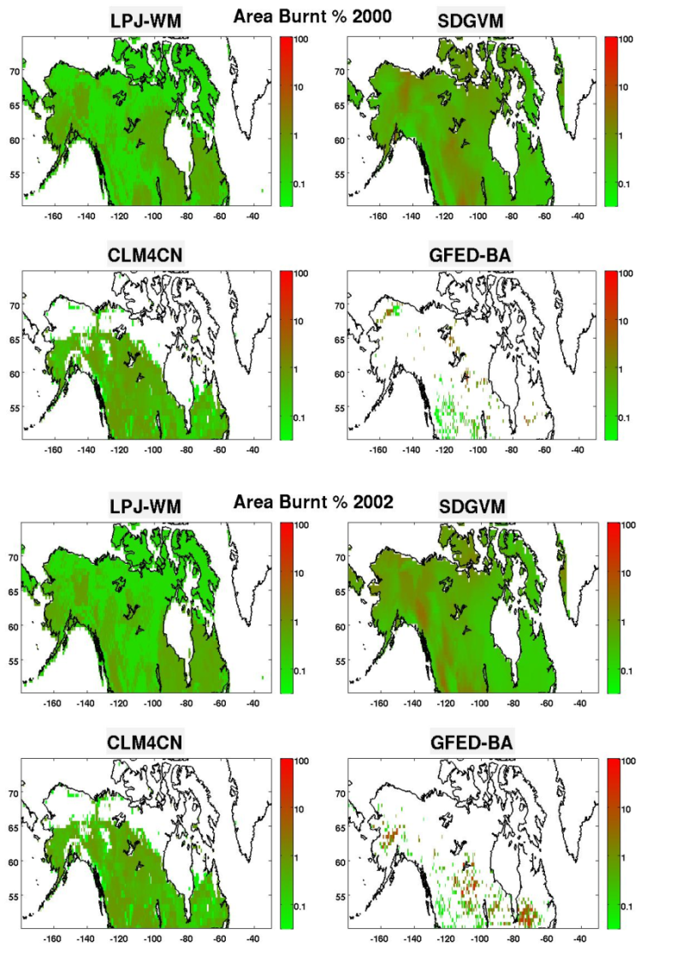

Figure 5:Percentage of burned area per grid cell in 2000 and 2002 over N. America for the three models and GFED-BA.

*Observed and modeled temporal variability in burned area*

**Fig. 6** (left) shows the total burned area in the pan-boreal region, N. America and Eurasia estimated by GFED-BA for 1997-2006, MODIS-BA for 2002-2006, and the three models for 1981-2006. Since GFED-BA exploits MODIS-BA, these two observational datasets are well correlated over their common time period from 2002-2009, but MODIS-BA produces more burned area in Eurasia and less in N. America [[*Giglio et al.*, 2010](#_ENREF_21); [*van der Werf et al.*, 2010](#_ENREF_63)]. In contrast, none of the models shows any significant correlation with GFED-BA for the overlapping period 1997-2006, either by continent or globally, as has previously been noted for CLM4CN over the pan-boreal region [[*Kloster et al.*, 2010](#_ENREF_29)]. The observations also exhibit markedly greater inter-annual variability than the model values, especially LPJ-WM and CLM4CN. Hence the mean values of the four estimates shown in **Table 4** do not really capture the model-data differences; for example, the global mean burned area in GFED-BA lies between the values from the three models, but values in some individual years are high and close to those from SDGVM, while other years give much lower values that tend to be closer to those from the other two models. Amongst the models, and as expected from **Table 4**, CLM4CN and LPJ-WM produce similar burned areas, with those from LPJ-WM always being higher, while SDGVM consistently produces much larger values (50-100% more, globally and in each continent).

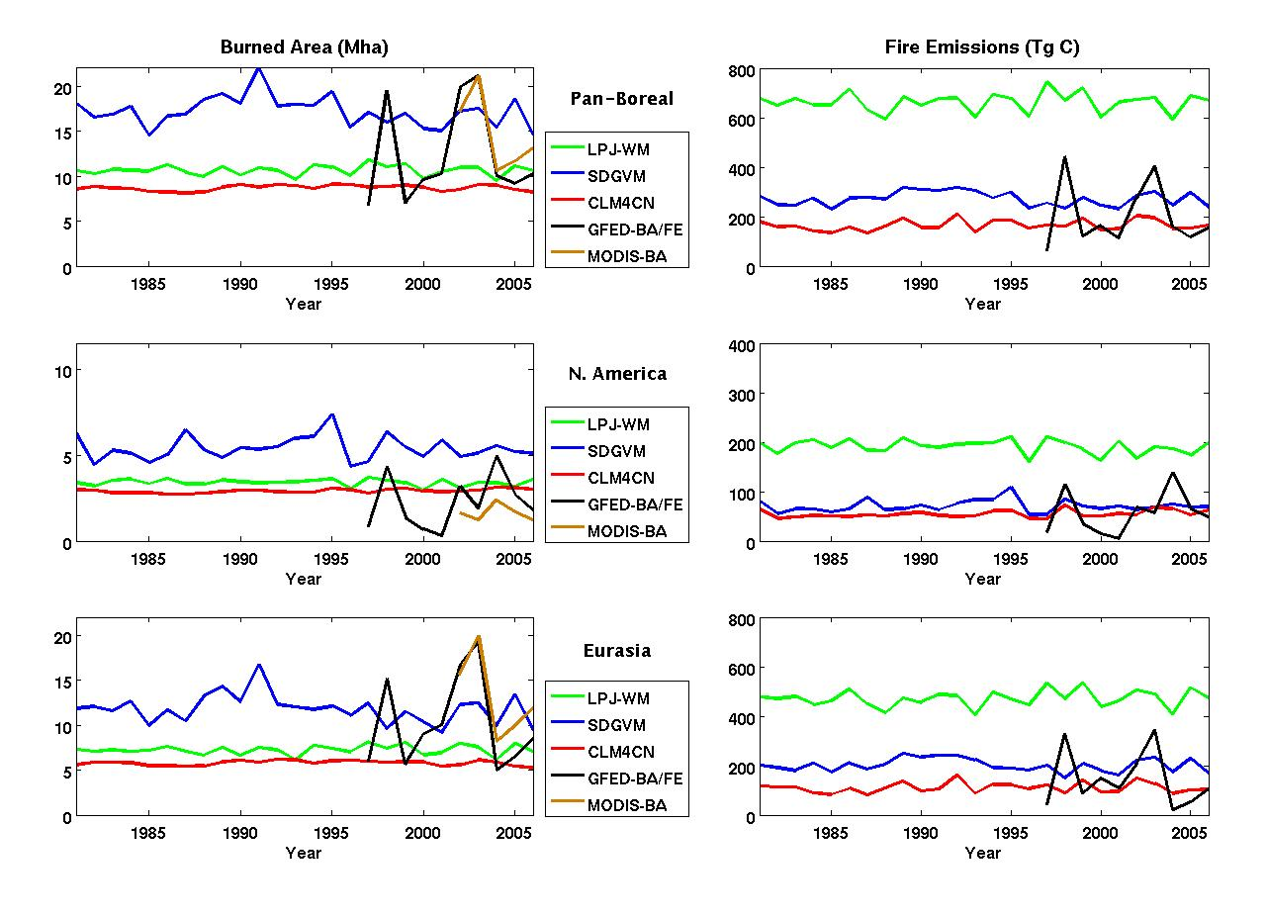

Figure 6:(left) Total area burnt per year (Mha yr-1) for the pan-boreal region, N. America and Eurasia as calculated by the three models and given by GFED-BA and MODIS-BA; (right) the corresponding fire emissions (Tg C yr-1) for the models and GFED.

The peak in burned area in N. America for 2002 was caused mainly by two fire events, the Long Creek Fire in Alaska and the 2002 Quebec fires (see **Fig. 5**). In Canada, large fires made up only 3% of the total fires occurring from 1959-1999, but contributed 97% of the burned area [[*Stocks et al.*, 2002](#_ENREF_56)]. These rare events follow the law of small numbers and their occurrence is usually modelled by a Poisson distribution [[*Jiang et al.*, 2012](#_ENREF_26); [*Mandallaz and Ye*, 1997](#_ENREF_36)]. None of the models incorporates this random component or any random variable in fire parameterization, so treatment of fire is deterministic rather than stochastic. This is the main cause for their lack of variability, which is not apparent when FRI or annual average burn is used to compare model outputs with data.

## Estimated fire emissions

**Fig. 6** (right) shows the carbon emissions associated with the estimates of burned area for GFED and the three models. It is important to note that, while the burned area from GFED is derived from observations, the *emissions* are estimated using the CASA model, hence all four curves are model-based.

There are two striking differences between the burned area and emissions curves:

1. Despite LPJ-WM producing burned area that is comparable with CLM4CN and much less than SDGVM, its estimates of emissions are higher than those from the other two models by a factor 2 or greater, both globally and in each continent.
2. Although SDGVM gives much greater burned area than either of the other models, its emissions estimates are comparable to those of CLM4CN in N. America and only about 30% higher than CLM4CN in Siberia.

It can also be seen that the mean values from GFED, CLM4CN and SDGVM are comparable, and well below the mean emissions from LPJ-WM (see **Table 5**).

|  |  |  |  |  |
| --- | --- | --- | --- | --- |
| **Fire emissions (Tg C yr-1)** | LPJ-WM | SDGVM | CLM4CN | GFED |
| N. America | 192 | 71 | 55 | 56 |
| Eurasia | 471 | 201 | 110 | 144 |
| Global | 663 | 272 | 164 | 200 |

Table 5:Annual carbon emissions (Tg C yr-1) averaged over 1981-2006 for the three models over N. America, Eurasia and pan-boreal latitudes. Also shown are the emissions from GFED averaged over 1997-2009 for the same regions.

The relation between burned area and emissions is a function of available fuel (biomass, litter and carbonaceous soils) and the efficiency with which fires consume this fuel, so can be relatively complex at the local scale. However, at continental scales a fairly simple picture emerges, as can be seen from **Fig. 7**, which plots emissions against burnt area in N. America and Eurasia for each year from 1981-2006 for the three models, and emissions from GFED against burnt area from GFED-BA for 1997-2009. A best linear fit to each plot is also shown, whose slope gives the mean emissions per unit area burned, and can be interpreted as fire intensity. The slope, intercept and R2 value for each of the plots is given in **Table 6**.

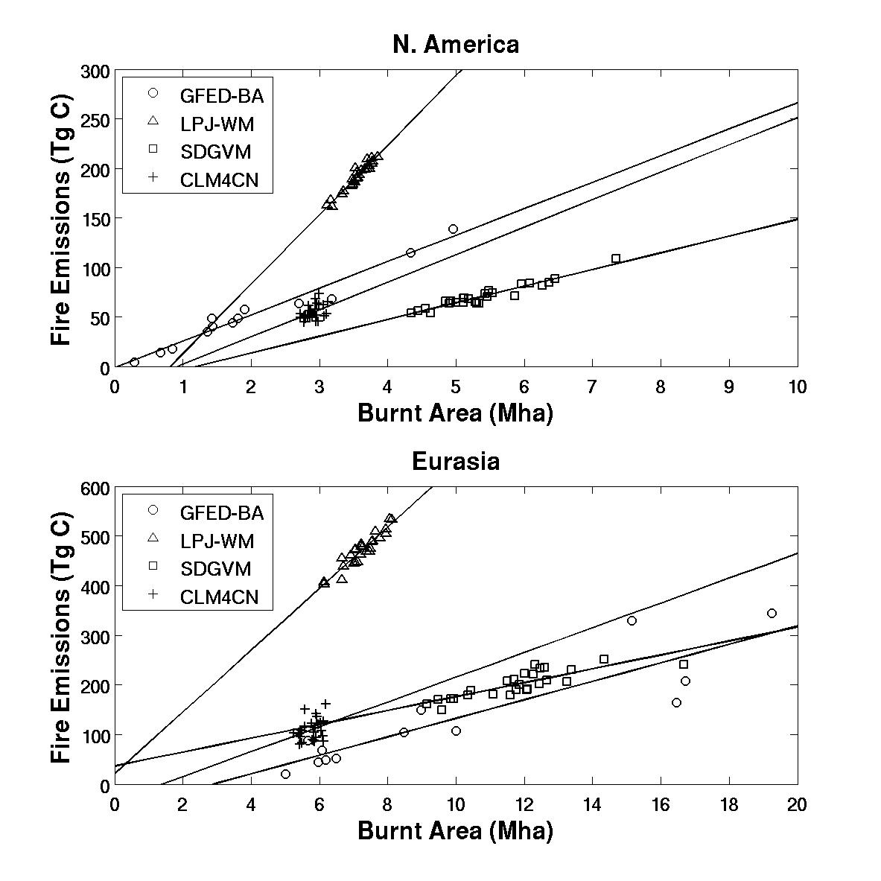

Figure 7:Regression of annual fire emissions (Tg C) against annual burned area (Mha) for the three DVMs (1981-2006) and GFED (1997-2009) over N. America and Eurasia.

|  |  |  |  |  |  |  |
| --- | --- | --- | --- | --- | --- | --- |
|  | N. America | | | Eurasia | | |
| **Slope**  **(kg C m-2)** | **Intercept**  **(Tg C yr-1)** | **R2** | **Slope**  **(kg C m-2)** | **Intercept**  **(Tg C yr-1)** | **R2** |
| GFED/GFED-BA | 2.7 | -1.6 | 0.97 | 1.9 | -54.1 | 0.80 |
| LPJ-WM | 7.0 | -58.0 | 0.94 | 6.2 | 20.7 | 0.89 |
| SDGVM | 1.7 | -20.1 | 0.92 | 1.4 | 36.3 | 0.69 |
| CLM4CN | 2.8 | -26.1 | 0.19 | 2.5 | -33.5 | 0.09 |

Table 6: Slopes, intercepts and R2 values for best linear fits to the plots of annual fire emissions vs burnt area for GFED and the three Dynamic Vegetation Models for N. America and Eurasia.

**Fig. 7** and **Table 6** bring out sharp differences both between models and between the models and data. Apart from CLM4CN, the relation between annual emissions and annual burnt area is almost linear, but the emissions per unit burnt area are much higher for LPJ-WM than for the other models. GFED indicates fires of significantly greater intensity than SDGVM in both N. America and in Eurasia, while the R2 value for CLM4CN is too low to assign any useful meaning to the calculated slope. All the estimates indicate that fires in N. America are more intense than in Eurasia; this agrees with studies by [[*Wooster and Zhang*, 2004](#_ENREF_68)], based on measurements of Fire Radiative Power, and has been attributed to the predominance of crown or canopy fires in N. America, while crawling or surface fires tend to dominate in Eurasia. With the exception of CLM4CN, the R2 values are very high in N. America but smaller in Eurasia; this may be because many fires in Eurasia occur at latitudes from 50-65°N (**Fig. 4**), where, even though herbaceous and tree cover are equally present overall, they are highly clustered, with herbaceous cover dominating the western part and forests the eastern. The difference in biomass between the two types causes a partial decoupling of burned area and fire emissions, a phenomenon which is also observed at global scale [[*van der Werf et al.*, 2006](#_ENREF_62)].

## Model parameterizations of fire emissions

These marked differences between the model estimates of carbon emissions do not stem from fundamental differences between the models, since they all use an approach that weights the area burned by the available fuel load, while factoring in variables that define the combustion process. However, the models make different assumptions about the fuel load and combustion completeness (defined as the fraction of burnt fuel that is emitted to the atmosphere), as summarized in **Table 7**. In addition, the models assign a fire mortality factor to each PFT, which defines the fraction of individuals in the burned area that will be affected by fire. LPJ-WM and CLM4CN assign similar values to this factor for each of the tree PFTs and the value 1 for herbaceous cover, while SDGVM assigns the value 1 to all PFTs.

|  |  |  |  |  |
| --- | --- | --- | --- | --- |
|  | **LPJ-WM** | **SDGVM** | **CLM4CN** | **GFED (CASA)** |
| Fuel load | AGB, BGB, litter | AGB only | AGB, BGB, litter | AGB, BGB, litter |
| Combustion completeness | Biomass: 100%  Litter: 100% | AGB: 80% | Leaves & fine roots: 100%  Stem & coarse roots: 20%  Litter: 100%  Woody debris: 40% | Leaves: 80-100%  Stems: 20-40%  Fine litter: 90-100%  Woody debris: 40-60%  Litter: 100% |

Table : Definitions of fuel load and combustion completeness in the three DVMs and in the CASA model used by GFED. AGB and BGB refer to above- and below-ground biomass respectively.

SDGVM is seen to treat only above-ground biomass as fuel, whereas LPJ-WM and CLM4CN include below-ground biomass and litter. Hence SDGVM has a lot less carbon available to burn, and thus yields much lower carbon emissions, despite burning around 60 - 100% more area (see **Table 4** and **Fig. 7**).

Even though LPJ-WM and CLM4CN produce similar burned areas, LPJ-WM yields carbon emissions that are more than four times greater. A major factor in this discrepancy comes from burning of litter, which accounts for 56% of the emissions (372 Tg C yr-1) in LPJ-WM, but only 30% (50 Tg C yr-1) in CLM4CN. Part of the reason for this large difference is that LPJ-WM has a much larger litter pool, with an average value of 103 PgC compared with 21 PgC for CLM4CN. However, LPJ-WM also treats litter as a single pool with combustion completeness 100%, while CLM4CN assigns different values of combustion completeness to coarse woody debris, leaf litter, etc. In particular, in CLM4CN the litter mainly consists of coarse woody debris, for which the combustion completeness is only 40%.

Differences between LPJ-WM and CLM4CN also arise from emissions from biomass burning, whose average values are 290 Tg C yr-1 in LPJ-WM and 114 Tg C yr-1 in CLM4CN. This can partly be attributed to LPJ-WM having 9.27x104 Tg C of biomass compared to 7.47x104 Tg C in CLM4CN, but more important is that LPJ-WM assumes complete combustion of above- and below-ground biomass, while CLM4CN completely burns the leaves and fine roots but assigns a combustion completeness factor of only 20% to the stem and coarse roots [[*Oleson*, 2010](#_ENREF_40)]. Note that the more complex CLM4CN scheme is similar to that adopted by CASA (**Table 6**), hence the large differences between them (**Fig. 7**) reflect the very low variability in burned area in CLM4CN, together with differences in the carbon pools estimated in the models. However, we do not have access to the details of the CASA carbon calculations underlying the GFED estimates, hence cannot provide quantitative assessment of these differences.

Overall, it is clear that the models disagree markedly about the relative importance of emissions from litter and from biomass: LPJ-WM produces 28% more emissions from litter than biomass, CLM4CN produces 66% less, while the whole of the 272 Tg C yr-1 emitted by fire from SDGVM comes from burning above-ground biomass.

# Discussion

The results in Section 4 show that:

* The large spatial and temporal variability in fire occurrence observed in satellite data is very poorly represented in all the models except GFED, which is data-driven.
* There is a nearly linear relationship between burnt area and emissions for all models except CLM4CN, which exhibits little variability in each quantity and very low correlation between them. The fire severity, defined as the emissions per unit area burned, is much greater in LPJ-WM than in the other models.
* The marked differences between the fire emissions from each model arise from the assumptions made about the components of the available fuel load and how completely each component burns.

These observations immediately raise important questions about the representations of high-latitude carbon processes in models and hence the ability of models to provide meaningful predictions under a changing climate. These include:

* Are there empirical data on the sizes of the carbon pools available as fuel in the boreal zone and their combustion completeness, and can these be used to test the models?
* Does the models’ failure to capture the spatio-temporal variability in fire matter when estimating the effects of fire on high-latitude processes and quantities, such as NBP, biomass and the dynamics of permafrost?
* Can the models be reparameterised to conform better with observational data, and what are the consequences?

## Available data on fire processes at high latitudes

As noted by [[*van der Werf et al.*, 2010](#_ENREF_63)], the accuracy of fire emissions estimates is limited by the available information on combustion completeness and emission factors, which is sparse and unsystematic and typically refers to specific fire events [[*Mack et al.*, 2011](#_ENREF_34)] or experimental fires [[*FIRESCAN*, 1996](#_ENREF_14)]. The available studies show that consumption of both biomass and litter by fire varies greatly, depending on environmental factors, the types of fire and the type of ecosystem. Several investigators have parameterized combustion completeness according to fire severity and fire type. For example, in [[*Conard and Ivanova*, 1997](#_ENREF_7)] the combustion completeness values for both understory vegetation and litter are taken to be 100% in high severity canopy fires, 90% and 50% respectively for high severity surface fires, and 50% and 10% respectively for low severity surface fires; about 15% of the woody biomass is consumed in canopy fires but this concerned a specific tree species. [[*Soja et al.*, 2004](#_ENREF_54)] reported typical values of soil organic matter consumed by high, medium and low severity fires as 5, 2 and 1 cm in a standard scenario and 10, 4 and 2 cm in an extreme scenario.

Although sparse, these observations suggest that the more complete parameterization of fuel load in CLM4CN and CASA is likely to be more realistic, but that the assumed independence between combustion completeness and fire severity is inconsistent with data. For the DVMs, which internalize the fire process, severe fires effectively never occur under their present formulation; hence, an improved parameterization would be ineffective unless steps were also taken to more accurately represent the stochastic nature of fires in the boreal zone. For the data-driven fires in CASA, combustion completeness could be related to fire severity, but better fire modeling would be needed to yield a predictive capability.

## The effects of improving the spatio-temporal description of fire on estimates of high latitude processes

Two different approaches were used in order to give closer agreement between the models the observed spatio-temporal properties of fire. In the first, the temporal variability of SDGVM was forced to conform (in a statistical sense) with GFED-BA observations, and this allowed us to investigate the effects on NBP and biomass. In the second, we modified LPJ-WM to give more realistic spatial and temporal variability in its representation of burnt area, and used this to carry out a preliminary investigation of the consequences for permafrost. This use of different models represents the suitability of each model for the particular investigation and the availability of in-house computer code. SDGVM is relatively easy to modify at the process level and has a particularly simple relation between fire and emissions (see **Table 6**), so was well-suited to investigating the role of fire in the inter-annual variability of NBP. Of the two models, only LPJ-WM incorporates permafrost dynamics, so was the only one suitable for investigating fire-permafrost links.

### Modifications to the SDGVM and their consequences

The description of fire in SDGVM cannot be directly driven by GFED-BA data because, as in many DVMs, a spin-up (in this case, of 500 years) is required to bring the system to near-equilibrium before a transient run corresponding to current climate can take place; this needs a representation of the fire regime over the whole time period of the spin-up, together with the extra hundred years of the 20th century. As a result, to investigate the extent to which the inter-annual variability observed in GFED-BA could affect SDGVM calculations, we assume that the temporal statistics of burnt area observed at each location in GFED-BA are representative of the whole time period. To characterize this variability, the average annual fraction burnt over the years 1997-2006 was first calculated for every grid-cell, **x**, to give the quantity



where gfed(**x**, i) denotes the fraction of grid cell **x** burnt in year *i* in the GFED-BA data. Then the fluctuation of burnt area about the mean at grid cell **x** in year *i* was calculated by the scaling factor SF(**x**, *i*)



this yielded a map of scaling factors for year *i*. For each year of the SDGVM spin-up and the years preceding 1997, one of these ten maps was randomly chosen and at each grid cell the fire probability was scaled by the corresponding map value. In effect, the GFED-BA variance is added onto the (much smaller) variance that already occurs in the model. For the years 1997-2006, the observed scale factors are used at each grid cell. **Fig. 8** shows the corresponding burned area from GFED-BA for the pan-boreal region for 1997-2006, together with the estimates from both the unmodified SDGVM run and with the adjusted fire model, labeled SDGVM\*. Note that the modification only adjusts the inter-annual variation; no attempt has been made to match the mean burned area in the data and model.

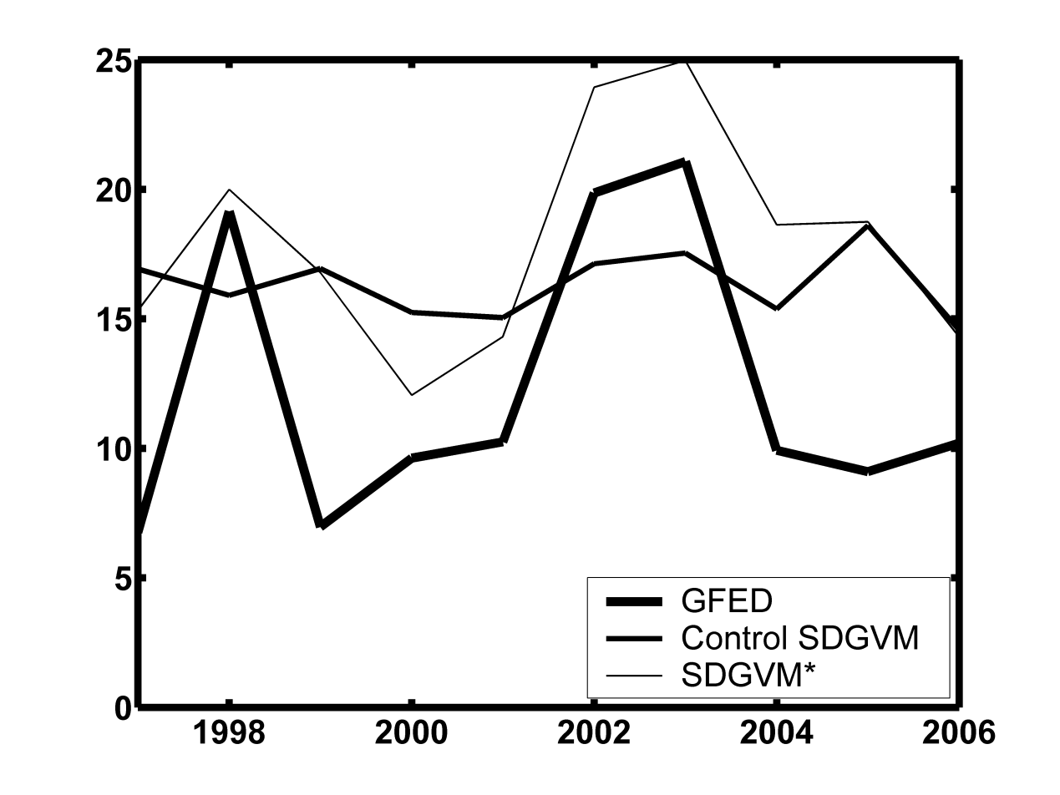

Figure 8: Burned area (in Mha) from GFED-BA, SDGVM and the SDGVM with the adjusted burnt area (denoted as SDGVM\*) for the pan-boreal region for 1997-2006.

*Effects on inter-annual variability of fire emissions and NBP*

Shown in **Fig. 9** are time series (1960-2006) of the de-trended NBP (lower plot) and fire emissions (upper plot) calculated by SDGVM and SDGVM\*. As expected, the inter-annual variability of the fire emissions increases significantly as a result of the increased variability in burnt area. However, the inter-annual variability of NBP is not significantly affected, and there is little correlation between NBP and the size of the emissions. Despite the variance of the NBP in the adjusted run increasing by 15.0%, only 22% of the adjusted NBP variance can be attributed to the variance of the adjusted fire emissions; this is inadequate for fire/non-fire years to affect the sign of the NBP and turn a sink year into a source and vice versa. Although the inter-annual variability of the burnt area now corresponds much more closely to that of the observations, the mean behavior and trends of burnt area, emissions and NBP are unaffected. In other words, for the pan-boreal region, fire emissions are not the major driver of the observed variability of land-atmosphere carbon exchange. This is consistent with the finding of [[*Prentice et al.*, 2011](#_ENREF_46)] that (at global scale) during 1997-2005, the CO2 fluxes produced by GFED would have contributed only a third of the variability in total CO2 flux inferred from atmospheric inversion, despite earlier studies postulating that biomass burning contributes greatly to land-atmosphere carbon flux anomalies [[*Nevison et al.*, 2008](#_ENREF_39); [*Patra et al.*, 2005](#_ENREF_41)]. In the case presented here, fire emissions contribute around 22% of the variability of the CO2 flux.

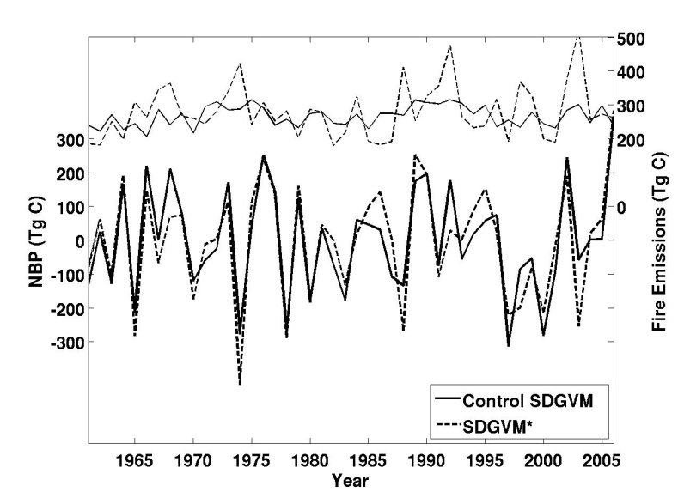

Figure 9:Time series (1960-2006) of the de-trended NBP (solid lines, left y-axis) and fire emissions (dashed lines, right y-axis) for SDGVM and its modified version, SDGVM\*.

*Effects on biomass*

The effects of increasing the inter-annual variability in burnt area on biomass are illustrated for the pan-boreal region in **Fig. 10**, which shows the difference between SDGVM and SDGVM\* as a percentage of the unmodified value. Although the overall effect is to slightly reduce overall biomass, the modified fire regime leads to a complex pattern of increases and decreases in the local mean biomass, essentially because it causes the occurrence of very large fires destroying large parts of the vegetation in many grid cells in some years, thus altering the age structure in the forest component of vegetation.

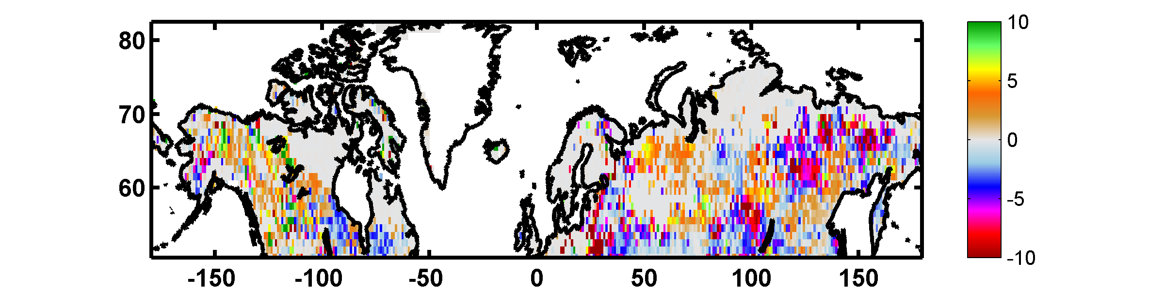

Figure 10:Percentage difference in biomass between modified and unmodified SDGVM calculations, i.e. 100 x (SDGVM\* – SDGVM) / SDGVM, averaged over 1997-2006.

### Modifications to LPJ-WM and their consequences for permafrost

In a boreal forest underlain by permafrost, [[*Dyrness et al.*, 1986](#_ENREF_13)] found that the active layer depth increased by 40-140 cm seven years after fire, and this effect can continue for 20-30 years [[*Viereck*, 1983](#_ENREF_64)]. The effects of fire on permafrost are also related to fire severity [[*Brown*, 1983](#_ENREF_4)]. The current parameterization of fire in models does not allow simulation of such processes, as the fraction of burnt area per grid cell does not exhibit the large values seen in the observations (see **Fig. 5**) and cannot cause changes of such magnitude.

To compensate, the LPJ-WM fire process was altered to give burnt area statistical properties that more closely resemble the GFED-BA data, but without changing the mean area burnt by the model. This was achieved by deriving the cumulative distribution function (CDF) of the annual fraction burnt per disturbed grid cell from GFED-BA,and forcing LPJ-WM to obey the same distribution; this modified version of LPJ-WM will be denoted as LPJ-WMa. At the 0.5° resolution of GFED-BA, the CDF of annual fraction burnt area per disturbed grid cell for boreal latitudes over the period 1997-2009 was found to be well approximated, by a gamma distribution of form:

 

with parameters  = 0.21 and *b* = 0.1 and expected value of 0.021. **Fig. 11** shows the observed CDF and that produced by LPJ-WMa over the same period and spatial subset. Note that the CDF will normally depend on the resolution of the dataset used to produce it.

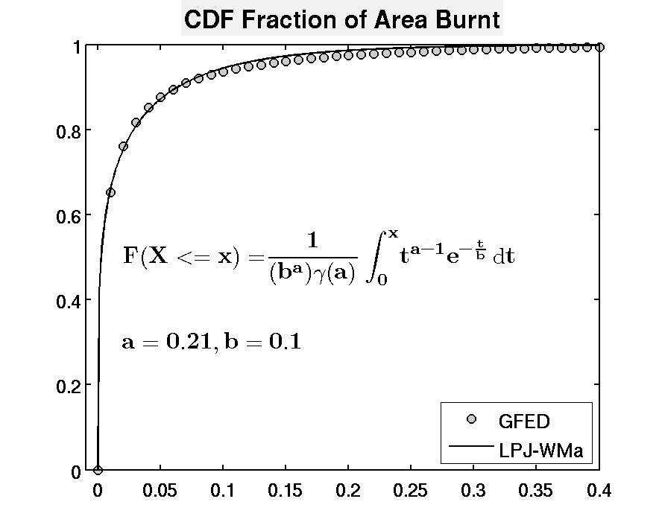

Figure 11:CDF of fractional annual burnt area per disturbed grid cell for GFED-BA and LPJ-WMa. On average, GFED-BA indicates about 8% of grid cells to be disturbed each year. Values with percentage burnt area exceeding 40% have probability less than 0.0012 so are omitted from the CDF plot.

For every grid cell in LPJ-WM, a random number, *p*, chosen between 0 and 1 with probability defined by the CDF, determines the fraction of the grid cell that will burn in the next fire. The annual fraction of burn produced by the original model is recursively aggregated, and the grid cell is not allowed to undergo any fire disturbance until the aggregate exceeds *p*. In the year when this occurs, a fraction of the grid cell equal to the cumulative percentage is allowed to burn; the process is then reset and repeated. This provides a more realistic representation of the temporal and spatial statistics of the observed fire regime without significantly affecting the magnitude of burnt area produced by LPJ-WM, which makes it readily adaptable for use in other models.

This modification affects permafrost dynamics, since LPJ-WM calculates soil temperature by numerically solving the one-dimensional heat diffusion equation using the Crank-Nicolson finite difference scheme in a column which incorporates snow, litter and 12 soil layers, with an upper boundary condition given by the air temperature and a lower boundary condition of stable temperature. Snow and litter act as insulators, reducing the heat exchange between the air and soil, but fire is assumed to remove 100% of the litter in the fraction of each grid cell that burns (see **Table 7**). Thus large fire events (e.g. area burnt > 50%) would be expected to have significant effects on soil temperature and hence on permafrost simply from heat diffusion.

However, a further effect is that removal of canopy by fire alters the radiation budget: for example, prior to disturbance, 30-65% of incoming solar radiation reaches the forest floor in black spruce forests [[*Slaughter*, 1983](#_ENREF_53)], while after a fire it exceeds 90% [[*Kasischke et al.*, 1995](#_ENREF_28)]. This effect cannot be simulated by the current version of LPJ-WM, which lacks a full radiation balance in the energy calculations. Hence a rough approximation was made in which the input air temperature, which acts as an upper boundary condition for the heat diffusion equation, was increased in the year after a fire and decreased as an exponential function of tree cover. This simulates an increase of Leaf Area Index and associated attenuation of radiation according to Beer-Lambert’s Law.

The cumulative effect of these two modifications is illustrated by **Fig. 12**, in which the upper plot shows the monthly soil temperatures at depth of 10 cm calculated by LPJ-WMa at a location dominated by deciduous needle-leaved forest in northern Siberia after a fire with 99% fraction of burn. Following the disturbance, the model initially sets herbaceous cover as the dominate PFT in the grid cell, while the needle-leaved PFT becomes dominant after 15 years. **Fig. 12** shows that the removal of litter and its subsequent damping effect increases the monthly variability of soil temperature as it becomes more susceptible to air temperature and its periodic fluctuations. Since summer soil temperatures now exceed 0° C, summer thaw depth increases by over 1.0 m and requires more than 60 years to return to its pre-disturbed value; this is more consistent with field data than when the boundary conditions were unchanged, in which case the increase in maximum thaw depth due to loss of litter is less than 0.5 m, although the time to recovery of the original temperature conditions is the same (see **Fig. 12**).

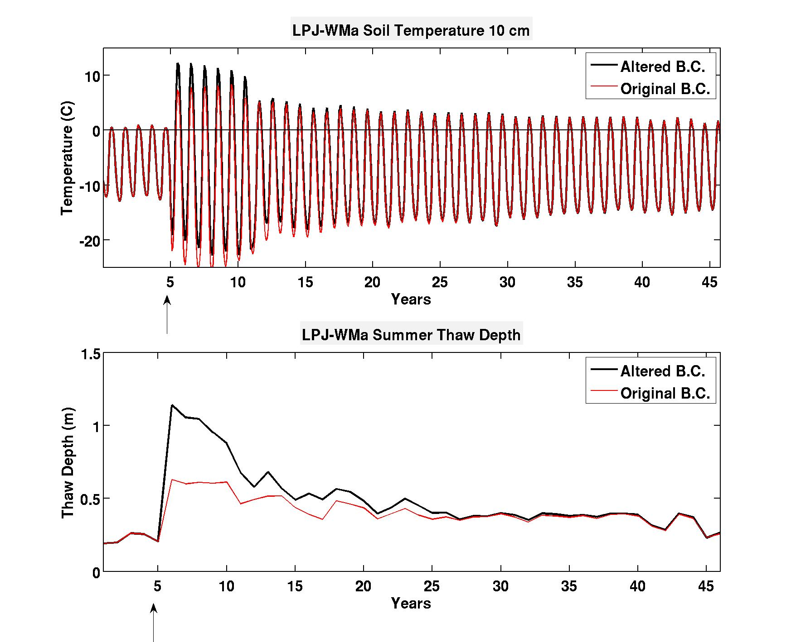

Figure 12: (top) Monthly soil temperatures for altered and original boundary conditions (B.C.) at depth of 0.1 m produced by LPJ-WMa at a site which experienced more than 99% of burn; the arrow marks the year of the fire disturbance. (bottom) Thaw depth averaged over summer months for the same sites.

Although the modifications to LPJ-WM provide more realistic simulations of permafrost dynamics following a fire, the current model formulation cannot capture the full extent of fire-permafrost interactions, e.g., thaw depth increases for several years after a fire, not only in the immediately following year, as in **Fig. 12** [[*MacKay*, 1970](#_ENREF_35); [*Yoshikawa et al.*, 2002](#_ENREF_70)]. However, this could be achieved if fire were treated as a continual process, rather than its effects being calculated in a single annual step as at present. Clearly the radiation balance also needs to be treated properly, rather than in the ad hoc approach used here to illustrate its importance.

## Land cover effects on NBP and fire processes

A source of uncertainty in model estimates of both NBP and fire emissions is land cover. We here briefly assess this by driving SDGVM with four of the most widely used global land cover datasets: Globcover, GLC2000, MODIS LC and the Vegetation Continuous Field (VCF) product derived from MODIS (see Section 3.1). The resulting average fluxes making up the carbon balance of the pan-boreal region over the period 1981-2006 are presented in **Fig. 13** (bottom). Despite large differences in the proportions in the three generic land cover types, tree, herbaceous and bare cover, in the land cover maps (**Fig. 13**(top)), NPP and Rh show differences of only a few per cent between the various land covers. Larger differences occur in NEP and fire emissions. Since SDGVM treats only above-ground biomass as fuel (see **Table 7**), fire emissions are roughly linearly proportional to tree cover, so the largest difference is between GLC2000 (40% tree cover) and MODIS VCF (25% tree cover), with the latter giving almost 50% lower emissions. NBP for pan-boreal latitudes was found to be well-approximated (adjusted R2 = 0.69) by a linear function of tree and grass cover given by:

NBP = 6.82(±1.96) x (Tree Cover) + 2.98(±1.31) x (Grass Cover)

with NBP in units of 1014 gC yr-1 and cover expressed as a fraction between 0 and 1. This leads to differences of 20% between the lowest carbon uptake (GlobCover) and highest (GLC2000); GlobCover has the highest fraction of bare ground, while GLC2000 has the least bare ground and the highest amount of tree cover.

figure_13.tif

Figure 13: (top) Pan-boreal fractions of three generic cover types (trees, herbaceous cover and bare ground) derived from the four land cover maps. (bottom) Average values of pan-boreal NPP, Rh, NEP, fire emissions and NBP calculated by SDGVM over the period 1981-2006 when driven with GlobCover, MODIS VCF, MODIS LC and GLC2000.

# Conclusions

Fire is an endemic process at high latitudes, connected to a range of other land surface properties, such as land cover, biomass and permafrost, and intimately linked to the carbon balance of the high latitude land surface. Much of our current understanding of these links and their climate consequences is through land surface models, so it is essential to ensure that the process representations and parameterizations in these models are consistent with observations; only then will they are able to provide trustworthy predictions for a changing climate. Over the vast pan-boreal region, a key source of information on fire is satellite data. Comparisons between satellite-based burnt area data from the Global Fire Emissions Database (GFED) and three DVMs (LPJ-WM, CLM4CN, SDGVM) indicate that all models fail to represent the observed spatial and temporal properties of the fire regime, and that there are large discrepancies between models and data as regards average annual burnt area. Although the three DVMs give comparable values of the boreal Net Biome Production (NBP), fire emissions are found to differ by a factor four between the models, because of widely different estimates of burnt area and because of different parameterizations of the fuel load and combustion process. Including a more realistic representation of the fire regime in the models shows that, for northern high latitudes: i) severe fire years do not coincide with source years or vice versa; ii) the inter-annual variability of fire emissions does not significantly affect the inter-annual variability of NBP; iii) overall biomass values alter only slightly, but the spatial distribution of biomass exhibits changes. We also demonstrate that it is crucial to alter the current representations of fire occurrence and severity in land surface models if the links between permafrost and fire are to be captured, in particular the dynamics of permafrost properties, such as active layer depth. This is especially important if models are to be used to predict the effects of a changing climate, because of the consequences of permafrost changes for greenhouse gas emissions, hydrology and land cover. Uncertainties about land cover introduce significant uncertainties into estimates of the absolute sizes of NBP and fire emissions, but do not change the above conclusions.

This study highlights two areas where further work is clearly needed. The first is improved experimental data on fire processes at high latitudes, as regards the pools entrained in fire events and the combustion completeness of these pools. Lack of knowledge about these factors is a major source of uncertainty in model estimates, both in the DVMs and in GFED (through CASA). This is a not fundamental weakness of the models, only of the parameter settings within their representations of fire, particularly for CLM4CN and CASA, which already contain a comprehensive description of the pools contributing to the fuel load.

However, there are fundamental limitations in the current ways that fire occurrence and fire severity are represented in the models, with follow-on consequences for the need for better energy balance representations if models are to be capable of predicting permafrost dynamics and associated effects on greenhouse gas emissions, hydrology and land cover. Removing these limitations constitutes the second major area where further work is needed. This has two components:

1. Formulation of models for fire occurrence and severity that more realistically capture the observed high variability in space and time of high latitude fires. A purely statistical approach has been used in this paper to assess the importance of representing such variability; its most significant effect, within the limits of our study, appears to be on permafrost. However, for predictive purposes under changing climate a more mechanistic approach may be preferable, with a stochastic component related to ignition probabilities.
2. More complete models for energy balance after fire are needed, to include the effects of both heat diffusion and radiation. Failure to include the latter leads to errors in the predicted mean soil temperature and to large underestimates of the time for permafrost to recover after fire. This may also require better representations of vegetation, for example to include the thermal consequences of a moss layer.

# References

Arino, O., S. Casadio, and D. Serpe (2012), Global night-time fire season timing and fire count trends using the ATSR instrument series, *Remote Sens Environ*, *116*, 226-238, doi: 10.1016/j.rse.2011.05.025.

Arino, O., P. Bicheron, F. Achard, J. Latham, R. Witt, and J. L. Weber (2008), GLOBCOVER The most detailed portrait of Earth, *Esa Bull-Eur Space*(136), 24-31.

Bartholome, E., and A. S. Belward (2005), GLC2000: a new approach to global land cover mapping from Earth observation data, *Int J Remote Sens*, *26*(9), 1959-1977, doi: 10.1080/01431160412331291297.

Brown, R. J. E. (1983), Effects of fire on permafrost ground thermal regime, in *The role of fire in northern circumpolar ecosystems*, edited by R. W. Wein and D. A. MacLean, pp. 97-110, Jown Wiley, New York.

Christensen, J. H., B. Hewitson, A. Busuioc, A. Chen, X. Gao, I. Held, R. Jones, and R. K. Kolli (2007), Regional Climate Projections, in *Climate Change 2007: The Physical Science Basis. Contribution of Working Group I to the Fourth Assessment Report of the Intergovernmental Panel on Climate Change* edited by S. Solomon, D. Qin, M. Manning, Z. Chen, M. Marquis, K. B. Averyt, M. Tignor and H. L. Miller, pp. 847-940, Cambridge University Press, Cambridge, U.K.

Collins, W. D., et al. (2006), The Community Climate System Model version 3 (CCSM3), *J Climate*, *19*(11), 2122-2143.

Conard, S. G., and G. A. Ivanova (1997), Wildfire in Russian boreal forests - Potential impacts of fire regime characteristics on emissions and global carbon balance estimates, *Environ Pollut*, *98*(3), 305-313.

Corell, R. (2005), Arctic Climate Impact Assessment, *B Am Meteorol Soc*, *86*(6), 860-861.

Cox, P., and D. Stephenson (2007), Climate change - A changing climate for prediction, *Science*, *317*(5835), 207-208, doi: 10.1126/science.1145956.

Cramer, W., et al. (2001), Global response of terrestrial ecosystem structure and function to CO2 and climate change: results from six dynamic global vegetation models, *Global Change Biol*, *7*(4), 357-373.

Defries, R. S., et al. (1995), Mapping the Land-Surface for Global Atmosphere-Biosphere Models - toward Continuous Distributions of Vegetations Functional-Properties, *J Geophys Res-Atmos*, *100*(D10), 20867-20882.

Di Gregorio, A., and L. J. M. Jansen (2000), Land Cover Classification System: Classification Concepts and User Manual, FAO, Rome

Dyrness, C. T., L. A. Viereck, and K. Van Kleave (1986), Fire in taiga communities of interior Alaska, in *Ecological Series:forest ecosystems in the Alaskan taiga*, edited by K. Van Cleave, pp. 74-86, Springer.

FIRESCAN (1996), Fire Research Campaign Asia-North, in *Biomass Burning and Global Change*, edited by J. S. Levine, pp. 848-873, MIT Press, Cambridge, Mass.

Friedl, M. A., D. Sulla-Menashe, B. Tan, A. Schneider, N. Ramankutty, A. Sibley, and X. M. Huang (2010), MODIS Collection 5 global land cover: Algorithm refinements and characterization of new datasets, *Remote Sens Environ*, *114*(1), 168-182, doi: 10.1016/j.rse.2009.08.016.

Friedlingstein, P., et al. (2006), Climate-carbon cycle feedback analysis: Results from the C(4)MIP model intercomparison, *J Climate*, *19*(14), 3337-3353.

GCOS (2004), Implementation plan for the Global Observing System for Climate in support of the UNFCCC, GCOS–92, WMO Technical Document No. 1219, Geneva, WMO.

GCOS (2010), Implementation Plan for the Global Observing System for Climate in Support of the UNFCCC (2010 Update), WMO.

Gerten, D., S. Schaphoff, U. Haberlandt, W. Lucht, and S. Sitch (2004), Terrestrial vegetation and water balance - hydrological evaluation of a dynamic global vegetation model, *J Hydrol*, *286*(1-4), 249-270, doi: 10.1016/j.jhydrol.2003.09.029.

Giglio, L. (2010), MODIS Collection 5 Active Fire Product User’s Guide, Version 2.4, Department of Geography, University of Meryland.

Giglio, L., J. T. Randerson, G. R. van der Werf, P. S. Kasibhatla, G. J. Collatz, D. C. Morton, and R. S. DeFries (2010), Assessing variability and long-term trends in burned area by merging multiple satellite fire products, *Biogeosciences*, *7*(3), 1171-1186.

Gurney, K. R., et al. (2003), TransCom 3 CO2 inversion intercomparison: 1. Annual mean control results and sensitivity to transport and prior flux information, *Tellus B*, *55*(2), 555-579.

Hansen, M. C., R. S. DeFries, J. R. G. Townshend, M. Carroll, C. Dimiceli, and R. A. Sohlberg (2003), Global Percent Tree Cover at a Spatial Resolution of 500 Meters: First Results of the MODIS Vegetation Continuous Fields Algorithm, *Earth Interact*, *7*.

Hurtt, G. C., S. Frolking, M. G. Fearon, B. Moore, E. Shevliakova, S. Malyshev, S. W. Pacala, and R. A. Houghton (2006), The underpinnings of land-use history: three centuries of global gridded land-use transitions, wood-harvest activity, and resulting secondary lands, *Global Change Biol*, *12*(7), 1208-1229, doi: 10.1111/j.1365-2486.2006.01150.x.

IGBP (1990), The international geosphere-biosphere programme:a study of global change-the initial core projects,IGBP Global Change Report No.12, Stockhold, Sweden.

Jiang, Y., Q. Zhuang, and D. Mandallaz (2012), Modeling Large Fire Frequency and Burned Area in Canadian Terrestrial Ecosystems with Poisson Models, *Environmental Modeling & Assessment*, doi: 10.1007/s10666-012-9307-5.

Kanamitsu, M., W. Ebisuzaki, J. Woollen, S. K. Yang, J. J. Hnilo, M. Fiorino, and G. L. Potter (2002), Ncep-Doe Amip-Ii Reanalysis (R-2), *B Am Meteorol Soc*, *83*(11), 1631-1643, doi: 10.1175/Bams-83-11-1631.

Kasischke, E. S., N. L. Christensen, and B. J. Stocks (1995), Fire, Global Warming, and the Carbon Balance of Boreal Forests, *Ecol Appl*, *5*(2), 437-451.

Kloster, S., N. M. Mahowald, J. T. Randerson, P. E. Thornton, F. M. Hoffman, S. Levis, P. J. Lawrence, J. J. Feddema, K. W. Oleson, and D. M. Lawrence (2010), Fire dynamics during the 20th century simulated by the Community Land Model, *Biogeosciences*, *7*(6), 1877-1902, doi: 10.5194/bg-7-1877-2010.

Lawrence, D. M., and A. G. Slater (2008), Incorporating organic soil into a global climate model, *Clim Dynam*, *30*(2-3), 145-160, doi: 10.1007/s00382-007-0278-1.

Lawrence, D. M., A. G. Slater, V. E. Romanovsky, and D. J. Nicolsky (2008), Sensitivity of a model projection of near-surface permafrost degradation to soil column depth and representation of soil organic matter, *J Geophys Res-Earth*, *113*(F2), doi: 10.1029/2007jf000883.

Lawrence, D. M., et al. (2011), Parameterization Improvements and Functional and Structural Advances in Version 4 of the Community Land Model, *J Adv Model Earth Sy*, *3*, doi: 10.1029/2011ms000045.

Le Quere, C., et al. (2009), Trends in the sources and sinks of carbon dioxide, *Nat Geosci*, *2*(12), 831-836, doi: 10.1038/Ngeo689.

Mack, M. C., M. S. Bret-Harte, T. N. Hollingsworth, R. R. Jandt, E. A. G. Schuur, G. R. Shaver, and D. L. Verbyla (2011), Carbon loss from an unprecedented Arctic tundra wildfire, *Nature*, *475*(7357), 489-492, doi: 10.1038/Nature10283.

MacKay, J. R. (1970), Disturbances to the tundra and forest tundra environments of the western Arctic, *Canadian Geotechnical Journal*, *7*(4), 420-432.

Mandallaz, D., and R. Ye (1997), Prediction of forest fires with Poisson models, *Can J Forest Res*, *27*(10), 1685-1694.

McGuire, A. D., J. M. Melillo, D. W. Kicklighter, and L. A. Joyce (1995), Equilibrium responses of soil carbon to climate change: Empirical and process-based estimates, *J Biogeogr*, *22*(4-5), 785-796.

McGuire, A. D., L. G. Anderson, T. R. Christensen, S. Dallimore, L. D. Guo, D. J. Hayes, M. Heimann, T. D. Lorenson, R. W. Macdonald, and N. Roulet (2009), Sensitivity of the carbon cycle in the Arctic to climate change, *Ecol Monogr*, *79*(4), 523-555.

Nevison, C. D., N. M. Mahowald, S. C. Doney, I. D. Lima, G. R. Van der Werf, J. T. Randerson, D. F. Baker, P. Kasibhatla, and G. A. McKinley (2008), Contribution of ocean, fossil fuel, land biosphere, and biomass burning carbon fluxes to seasonal and interannual variability in atmospheric CO(2), *J Geophys Res-Biogeo*, *113*(G1), doi: 10.1029/2007jg000408.

Oleson, K. W. (2010), Technical Description of version 4.0 of the Community Land Model, NCAR Technical Note 47, 257.

Patra, P. K., M. Ishizawa, S. Maksyutov, T. Nakazawa, and G. Inoue (2005), Role of biomass burning and climate anomalies for land-atmosphere carbon fluxes based on inverse modeling of atmospheric CO2, *Global Biogeochem Cy*, *19*(3), doi: 10.1029/2004gb002258.

Piao, S. L., J. Y. Fang, P. Ciais, P. Peylin, Y. Huang, S. Sitch, and T. Wang (2009), The carbon balance of terrestrial ecosystems in China, *Nature*, *458*(7241), 1009-U1082, doi: 10.1038/Nature07944.

Potter, C. S., J. T. Randerson, C. B. Field, P. A. Matson, P. M. Vitousek, H. A. Mooney, and S. A. Klooster (1993), Terrestrial Ecosystem Production - a Process Model-Based on Global Satellite and Surface Data, *Global Biogeochem Cy*, *7*(4), 811-841.

Poulter, B., D. C. Frank, E. L. Hodson, and N. E. Zimmermann (2011a), Impacts of land cover and climate data selection on understanding terrestrial carbon dynamics and the CO2 airborne fraction, *Biogeosciences*, *8*(8), 2027-2036, doi: 10.5194/bg-8-2027-2011.

Poulter, B., P. Ciais, E. Hodson, H. Lischke, F. Maignan, S. Plummer, and N. E. Zimmermann (2011b), Plant functional type mapping for earth system models, *Geosci Model Dev*, *4*(4), 993-1010, doi: 10.5194/gmd-4-993-2011.

Prentice, I. C., D. I. Kelley, P. N. Foster, P. Friedlingstein, S. P. Harrison, and P. J. Bartlein (2011), Modeling fire and the terrestrial carbon balance, *Global Biogeochem Cy*, *25*, doi: 10.1029/2010gb003906.

Quegan, S., C. Beer, A. Shvidenko, I. McCallum, I. C. Handoh, P. Peylin, C. Rodenbeck, W. Lucht, S. Nilsson, and C. Schmullius (2011), Estimating the carbon balance of central Siberia using a landscape-ecosystem approach, atmospheric inversion and Dynamic Global Vegetation Models, *Global Change Biol*, *17*(1), 351-365, doi: 10.1111/j.1365-2486.2010.02275.x.

Roberts, G. J., and M. J. Wooster (2008), Fire detection and fire characterization over Africa using Meteosat SEVIRI, *Ieee T Geosci Remote*, *46*(4), 1200-1218, doi: 10.1109/Tgrs.2008.915751.

Rodenbeck, C., S. Houweling, M. Gloor, and M. Heimann (2003), CO(2) flux history 1982-2001 inferred from atmospheric data using a global inversion of atmospheric transport, *Atmos Chem Phys*, *3*, 1919-1964.

Roy, D. P., L. Boschetti, C. O. Justice, and J. Ju (2008), The collection 5 MODIS burned area product - Global evaluation by comparison with the MODIS active fire product, *Remote Sens Environ*, *112*(9), 3690-3707, doi: 10.1016/j.rse.2008.05.013.

Serreze, M. C., and J. A. Francis (2006), The arctic amplification debate, *Climatic Change*, *76*(3-4), 241-264, doi: 10.1007/s10584-005-9017-y.

Sitch, S., et al. (2003), Evaluation of ecosystem dynamics, plant geography and terrestrial carbon cycling in the LPJ dynamic global vegetation model, *Global Change Biol*, *9*(2), 161-185.

Slaughter, C. W. (1983), Summer Shortwave Radiation at a Subarctic Forest Site, *Can J Forest Res*, *13*(5), 740-746.

Soja, A. J., W. R. Cofer, H. H. Shugart, A. I. Sukhinin, P. W. Stackhouse, D. J. McRae, and S. G. Conard (2004), Estimating fire emissions and disparities in boreal Siberia (1998-2002), *J Geophys Res-Atmos*, *109*(D14), doi: 10.1029/2004jd004570.

Stocks, B. J., et al. (1998), Climate change and forest fire potential in Russian and Canadian boreal forests, *Climatic Change*, *38*(1), 1-13.

Stocks, B. J., et al. (2002), Large forest fires in Canada, 1959-1997, *J Geophys Res-Atmos*, *108*(D1), doi: 10.1029/2001jd000484.

Tarnocai, C., J. G. Canadell, E. A. G. Schuur, P. Kuhry, G. Mazhitova, and S. Zimov (2009), Soil organic carbon pools in the northern circumpolar permafrost region, *Global Biogeochem Cy*, *23*, doi: 10.1029/2008gb003327.

Thonicke, K., S. Venevsky, S. Sitch, and W. Cramer (2001), The role of fire disturbance for global vegetation dynamics: coupling fire into a Dynamic Global Vegetation Model, *Global Ecol Biogeogr*, *10*(6), 661-677.

Thornton, P. E., J. F. Lamarque, N. A. Rosenbloom, and N. M. Mahowald (2007), Influence of carbon-nitrogen cycle coupling on land model response to CO(2) fertilization and climate variability, *Global Biogeochem Cy*, *21*(4), doi: 10.1029/2006gb002868.

Tjiputra, J. F., K. Assmann, M. Bentsen, I. Bethke, O. H. Ottera, C. Sturm, and C. Heinze (2010), Bergen Earth system model (BCM-C): model description and regional climate-carbon cycle feedbacks assessment, *Geosci Model Dev*, *3*(1), 123-141.

Turetsky, M., K. Wieder, L. Halsey, and D. Vitt (2002), Current disturbance and the diminishing peatland carbon sink, *Geophys Res Lett*, *29*(11), doi: 10.1029/2001gl014000.

van der Werf, G. R., J. T. Randerson, L. Giglio, G. J. Collatz, P. S. Kasibhatla, and A. F. Arellano (2006), Interannual variability in global biomass burning emissions from 1997 to 2004, *Atmos Chem Phys*, *6*, 3423-3441.

van der Werf, G. R., J. T. Randerson, L. Giglio, G. J. Collatz, M. Mu, P. S. Kasibhatla, D. C. Morton, R. S. DeFries, Y. Jin, and T. T. van Leeuwen (2010), Global fire emissions and the contribution of deforestation, savanna, forest, agricultural, and peat fires (1997-2009), *Atmos Chem Phys*, *10*(23), 11707-11735, doi: 10.5194/acp-10-11707-2010.

Viereck, L. A. (1983), The effects of fire in black spruce ecosystems of Alaska and northern Canada, in *The role of fire in northern circumpolar ecosystems*, edited by R. W. Wien and D. A. MacLean, pp. 201-220, Wiley & Sons Ltd.

Wania, R., I. Ross, and I. C. Prentice (2009), Integrating peatlands and permafrost into a dynamic global vegetation model: 1. Evaluation and sensitivity of physical land surface processes, *Global Biogeochem Cy*, *23*, doi: 10.1029/2008gb003412.

Woodward, F. I., and M. R. Lomas (2004), Vegetation dynamics - simulating responses to climatic change, *Biol Rev*, *79*(3), 643-670, doi: 10.1017/S1464793103006419.

Woodward, F. I., T. M. Smith, and W. R. Emanuel (1995), A Global Land Primary Productivity and Phytogeography Model, *Global Biogeochem Cy*, *9*(4), 471-490.

Wooster, M. J., and Y. H. Zhang (2004), Boreal forest fires burn less intensely in Russia than in North America, *Geophys Res Lett*, *31*(20), doi: 10.1029/2004gl020805.

Wooster, M. J., G. Roberts, G. L. W. Perry, and Y. J. Kaufman (2005), Retrieval of biomass combustion rates and totals from fire radiative power observations: FRP derivation and calibration relationships between biomass consumption and fire radiative energy release, *J Geophys Res-Atmos*, *110*(D24), doi: 10.1029/2005jd006318.

Yoshikawa, K., W. R. Bolton, V. E. Romanovsky, M. Fukuda, and L. D. Hinzman (2002), Impacts of wildfire on the permafrost in the boreal forests of Interior Alaska, *J Geophys Res-Atmos*, *108*(D1), doi: 10.1029/2001jd000438.

**END OF DOCUMENT**